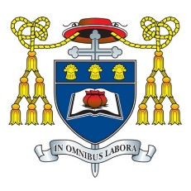
Headteacher: Mr C Burns, BA (Hons), PGCE, NPQH & NPQEL
Under the Trusteeship of the R.C Diocese of Shrewsbury

Greenbank Lane, Hartford, Northwich, Cheshire CW8 1JW
T: 01606 706000 E: admin@st-nicholas.cheshire.sch.uk
W: www.st-nicholas.cheshire.sch.uk

ST NICHOLAS
CATHOLIC
HIGH SCHOOL

September 2023

Dear Parents and Carers

Year 8 Day of Reflection – Wednesday 11th October

We are pleased to inform you that we will be hosting a Day of Reflection for all Year 8 students on the above date.

This has been an important year for our students at St Nicholas Catholic High School.
They have been settling into their studies and learning how to work together and support each other. The Day of Reflection gives them the opportunity for a time of reflection. The theme of the retreat is ‘Building the Kingdom’ and encourages our students to develop several interpersonal skills whilst making links with how faith can have a positive impact on the lives of others.

The retreat will take place during the normal school day so the students will be able to access break and lunch at the usual times. They will not require their schoolbooks but should remember to bring their Lunch Card and writing equipment. They will also need to bring trainers as some of the activities will take place in the sports hall.

The day is a very important part of the spiritual, moral, and social development programme for Year 8. We are sure that all students will benefit greatly from the day, and we appreciate your co-operation in encouraging your child to make the most of this opportunity.

Yours sincerely

Mrs N Azakli Mairie Gelling
Year 8 Year Leader Chaplain

