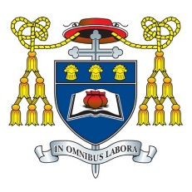
Headteacher: Mr C Burns, BA (Hons), PGCE, NPQH & NPQEL
Under the Trusteeship of the R.C Diocese of Shrewsbury

Greenbank Lane, Hartford, Northwich, Cheshire CW8 1JW
T: 01606 706000 E: admin@st-nicholas.cheshire.sch.uk
W: www.st-nicholas.cheshire.sch.uk

ST NICHOLAS
CATHOLIC
HIGH SCHOOL

Dear Parent/Carer

St Nicholas Catholic High School - Year 7 Family Welcome Mass
6.00pm Wednesday 4th October 2023

It has been wonderful seeing your child settling into St Nicholas Catholic High School in their first few weeks as a Year 7 student. We have enjoyed a really inspiring retreat day at St Wilfrid's parish church where the students were able to share their skills and talents, get to know each other a little better, and begin to prepare for their own special Year 7 Welcome Mass.

The Year 7 Welcome Mass is always one of our most memorable events of the year. This Mass gives all our new students an opportunity to contribute in creative and inspiring ways and to set their mark on this important year. As a family Mass we would like to invite you to come along and be part of the celebration.

The Mass begins at 6.00pm and takes place in school. All Year 7 students are expected to attend and should be in full school uniform. In order to help with seating we would be grateful if you could confirm your attendance and also how many seats you will require (including your child).

If you require any particular arrangements because of disability or infirmity, please do let us know.

We look forward to receiving your confirmation that you will be attending the Welcome Mass together with the number of seats required. https://forms.office.com/e/hMpM9Fv7pm If you could reply by Monday 2nd October.

Yours sincerely

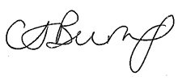
Mr Craig Burns
Headteacher

