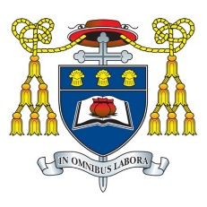
Headteacher: Mr C Burns, BA (Hons), PGCE, NPQH & NPQEL
Under the Trusteeship of the R.C Diocese of Shrewsbury

Greenbank Lane, Hartford, Northwich, Cheshire CW8 1JW
T: 01606 706000 E: admin@st-nicholas.cheshire.sch.uk
W: www.st-nicholas.cheshire.sch.uk

ST NICHOLAS
CATHOLIC
HIGH SCHOOL

Tuesday 26th September 2023

Dear Parent / Carer

I am writing to inform you that all students in Years 7-10 will be undertaking a reading test in English lessons next week, w/c 2nd October. The test is called the New Group Reading Test and is used by schools nationally to measure students’ current reading levels. The data it generates will allow us to ensure lessons are appropriately tailored to student ability, as well as helping to identify students who need further support with reading.

Students will be informed of this in English lessons this week. There is no revision or preparation involved in the test, which is completed electronically on laptops in approximately 30 minutes.

If you have any queries about this or any other aspect of English then please contact your child’s English teacher in the first instance.

Yours faithfully

Mr D Huws
Assosiciate Assistant Headteacher
Subject Leader of English

