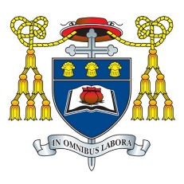
Headteacher: Mr C Burns, BA (Hons), PGCE, NPQH & NPQEL
Under the Trusteeship of the R.C Diocese of Shrewsbury

Greenbank Lane, Hartford, Northwich, Cheshire CW8 1JW
T: 01606 706000 E: admin@st-nicholas.cheshire.sch.uk
W: www.st-nicholas.cheshire.sch.uk

ST NICHOLAS
CATHOLIC
HIGH SCHOOL

20 April 2023

Dear Parents/Carers

NEU Industrial Action: Thursday 27 April and Tuesday 2 May 2023

You will know, from previous correspondence from Mr. Heffernan and Mr. Mottram, that the National Education Union (NEU) announced strikes on 4 dates. The NEU have since announced further strike dates on Thursday 27th April and Tuesday 2nd May 2023.

Firstly, as has been stressed previously, it is important to note that the NEU’s dispute is a national issue and not in any way directed at St Nicholas Catholic High School. The school’s absolute priority in such circumstances is the health and safety of all members of our school community, with the adequate supervision of students a fundamental consideration.

We can assure parents and carers that, based upon a range of complex factors, we have continued to model a range of different scenarios to explore all possibilities of different school opening types for Thursday 27 April and Tuesday 2 May. As you will appreciate, the school timetable differs on each day of the week and, as such, each day presents differing demands in terms of staffing coverage.

Therefore, we can confirm that school will be partially open on Thursday 27 April and Tuesday 2 May. Our provision on both days will be structured on the following basis:

Year Group | Provision
Years 12 & 13 | On-site attendance
Year 11 | On-site attendance
Years 7, 8, 9, 10 | Remote learning

Information for Students Attending On-Site Provision on Thursday 27 April and Tuesday 2 May
School transport will operate as usual to enable Year 11, 12, and 13 students to travel into school in the normal manner. Catering arrangements will also operate as usual.

Information for Students Accessing Remote Learning on Thursday 27 April and Tuesday 2 May
We remain committed to offering educational provision for students in Years 7, 8, 9, and 10 on the days of strike action and will be providing remote education for these Year Groups, which will be accessed via Microsoft Teams.

Students will be expected to follow their regular timetable of subjects online for the day and, wherever possible, they will have live lessons with their teacher. In the instance of a teacher being unavailable, students will be guided towards online work for that lesson.

Students received a virtual assembly prior to the previous strike days outlining how to access the remote learning package and expectations regarding engagement and conduct during the online lessons.

We are blessed with the positive behaviour of our students and we were proud of the manner in which they conducted themselves during remote learning. Please do continue to support us by reinforcing the message of appropriate online conduct to your children at home during the day.

Free School Meals

Families whose children will be participating in remote learning and are in receipt of free school meals provision will receive electronic food vouchers to the value of the daily allowance. These will be distributed shortly.

Future Strike Dates

If there are any changes announced by the NEU regarding their industrial action on these two dates, we will respond and updated you accordingly.

As ever, we thank you for your support and understanding.
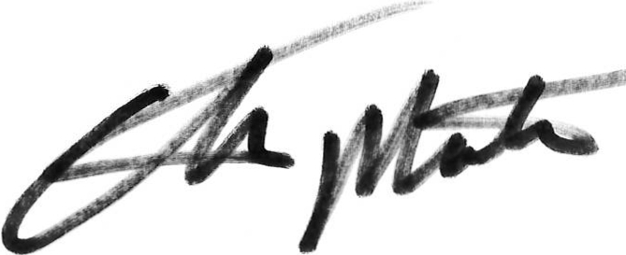

Craig Burns Chris Mottram
Headteacher Chair of Governors

