Parent Guide for St Nicholas Catholic High School

A Parent's Guide to Getting Started with “Edulink One”
All schools have their own way of working with Edulink One. It is customisable, meaning each school can tailor the product to meet their individual needs. The features covered in this guide are subject to the options your school chooses to use and should be viewed with this in mind. We request that users contact their school directly with any questions they may have.
There are two ways to use Edulink One: through a web browser like Google Chrome or through an app you can download to use on your mobile device. The Edulink One app is available for iOS and Android devices.

Web Browser Instructions
This is your school’s individual login link if you use a browser to log in.
Start by going to https://www.edulinkone.com/#!/login?id=YYYY or if you are not using your school’s direct link, visit https://www.edulinkone.com/.
After clicking the link this will take you straight to the Edulink One login page for your school.
If you do not have a direct link, you will need to enter your School ID or Postcode and press Next. Your School ID will have been sent to you by the school. If you forget your username or password, please contact the school.
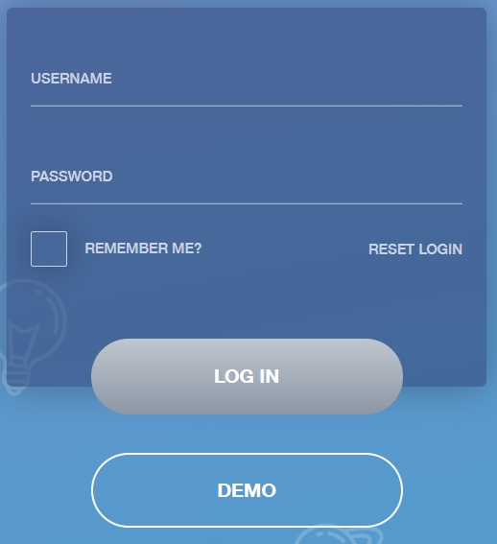
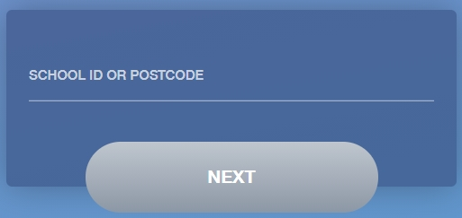
Enter your Username and Password that the school has sent to you.
If you have not received an email with your login details, please contact your school to resolve this issue.
Once you have filled in the username and password boxes with your login details, click LOG IN to get started.

Downloading and Using the App
The Edulink One app is available for iOS and Android devices. You can download from these links or search in the App or Play stores.
Apple App Store
https://itunes.apple.com/gb/app/edulink-one/id1188809029?mt=8&ign-mpt=uo%3D4
Android Google Play
https://play.google.com/store/apps/details?id=com.overnetdata.edulinkone&hl=en
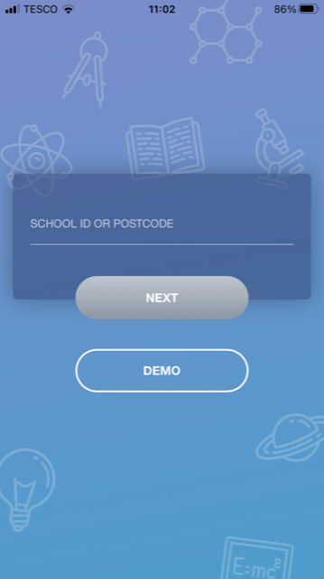
If you are using the mobile app you will see the screen to the left. You must input your School ID or Postcode and click the Next button to continue.
This is followed by the USERNAME and PASSWORD screen where you need to enter the login details your school has sent you.
Once you have filled in all three boxes with your login details, click LOG IN to get started.
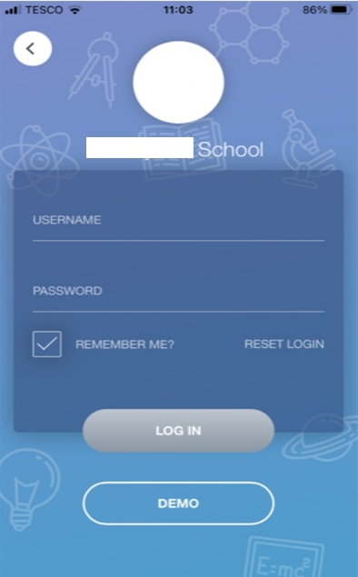
If you forget your username or password, please contact the school

Main Screen
Once logged in, you will see the main screen in Edulink One. The information held in your account relates to your child/children. You will be able to navigate through the different sections of Edulink One by clicking on the icons, e.g. to view your child’s attendance, click the Attendance icon.
Please see an example of the main screen below. The options may vary between schools as not all schools use all Edulink One’s functions.
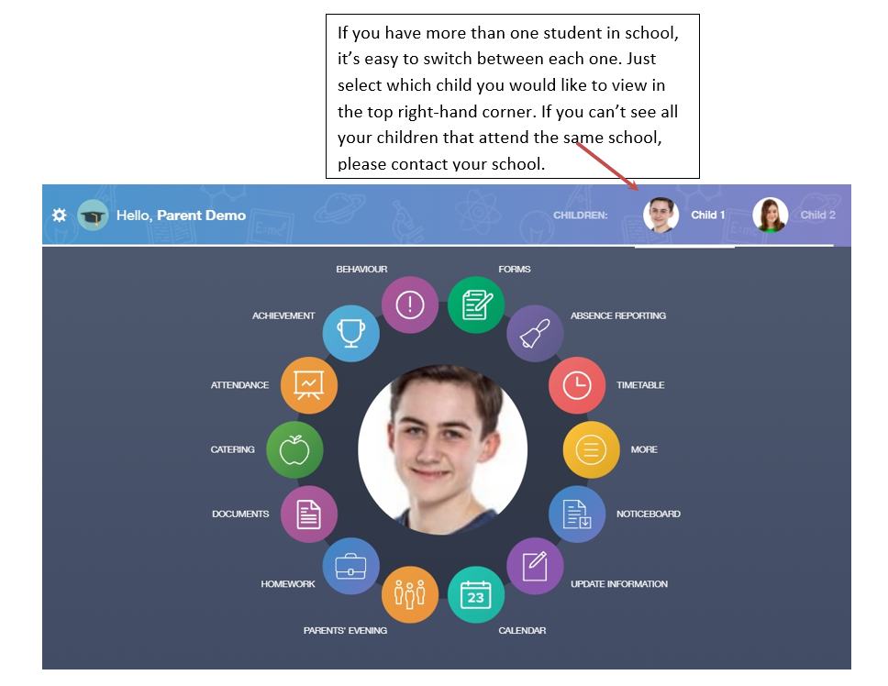
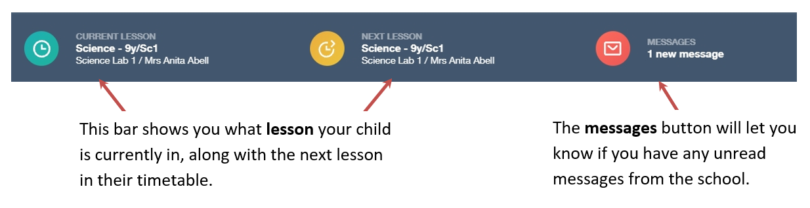

Catering
Here you can check the remaining balance of your child’s school cashless catering account. Details of purchased items from the canteen are also broken down into a list including dates and times so you can see what your child has purchased each day.
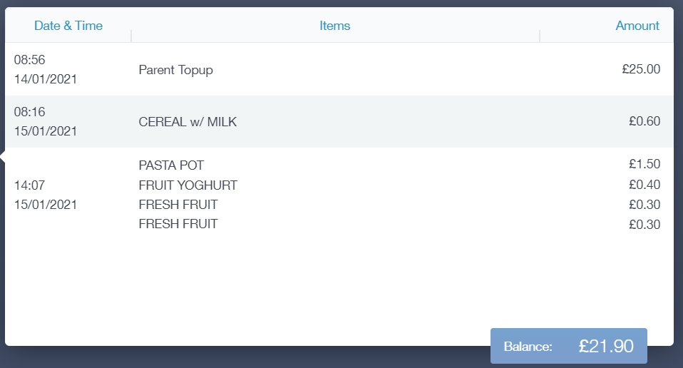

Documents
In this section you will find all the individual reports related to your child.
This includes profile reports and progress checks. Historical reports from previous years will be stored here and will be available for you to download in PDF format whenever you choose.

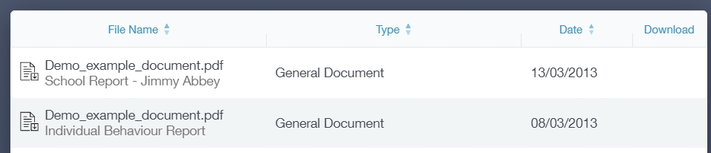

Medical Info
This section contains medical information that you have supplied to the school regarding your child. Details on medical conditions, medical notes, medical practices, and medical events such as appointments can all be viewed here. Allergy lists and other attachments can be downloaded in PDF format.
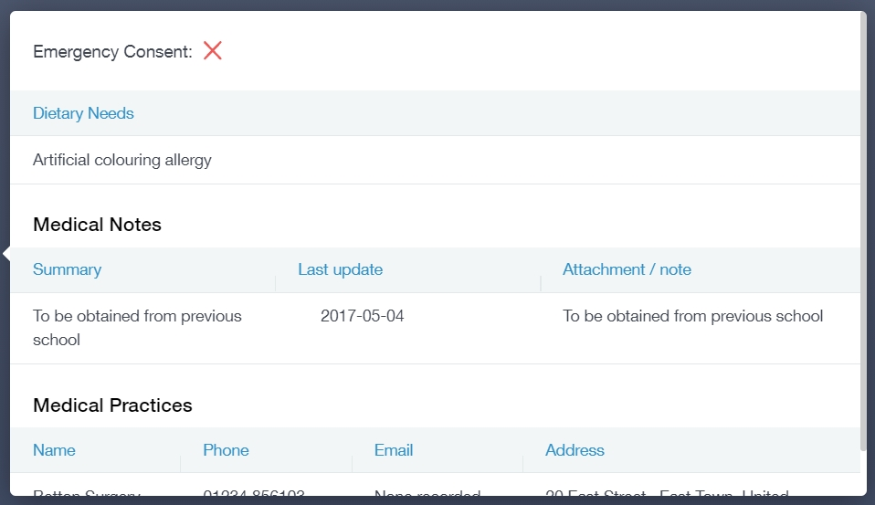

Update Information
This section shows you the contact information that the school has on record for yourself and your children.
Here you can review the contact information the school holds for you, but you will also be able to update this with any changes that may occur to this information. When updated information is submitted through Edulink One, this will be picked up by the designated personnel in school in charge of updating records. It will be checked by them and approved.
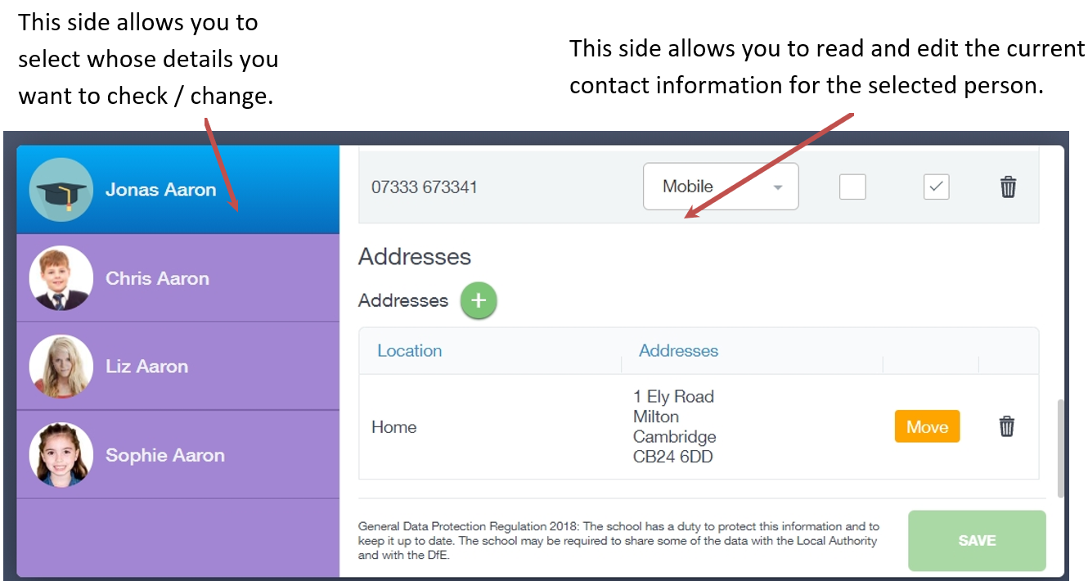
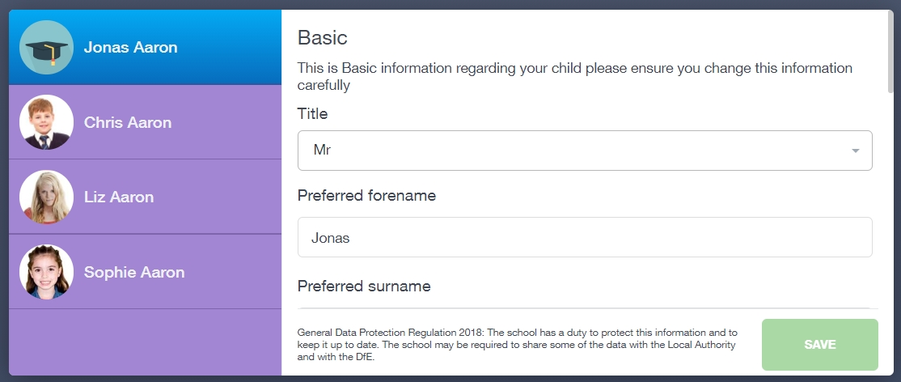
To update information using the Edulink One app on a mobile phone, click on the Data Collection/ Update Information icon and the screen will open.
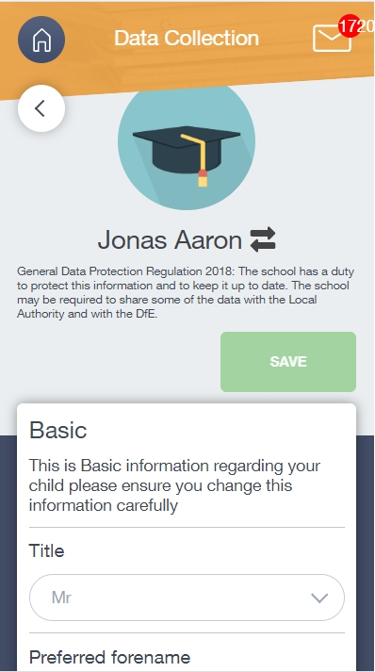

To update your own information, simply fill out the fields under your name. If you need to update information for a child, you need to click on the Switch Account arrows beside your name. Then, select the child you need to update the information for. Fill out the information in the fields as usual.
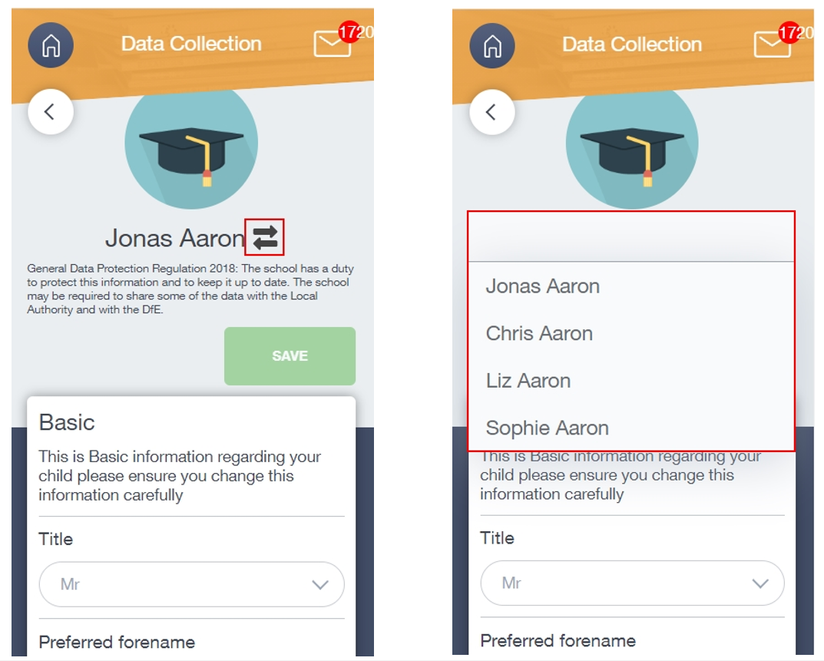

Timetable
Parents and students both have access to this section, which allows you to view your child’s school timetable. This shows you information on what lessons your child has each day and who the teachers are for those lessons.

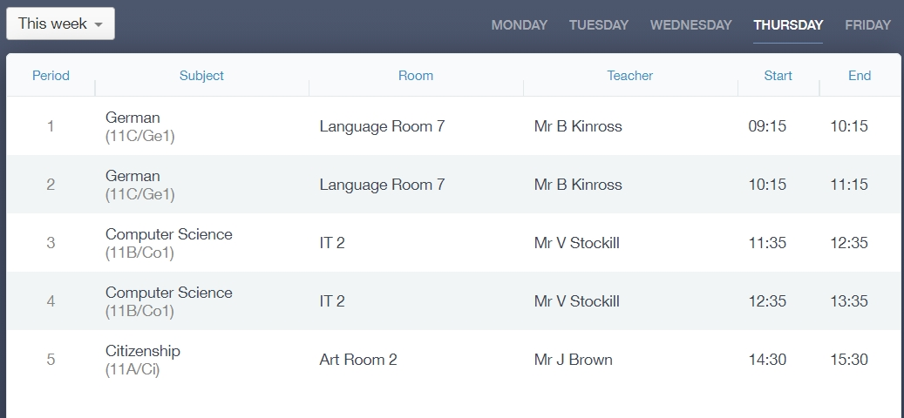

Account Info
Here you can view the current address details the school has on file for your child. Other information on your child’s year group, house and tutor are also available.

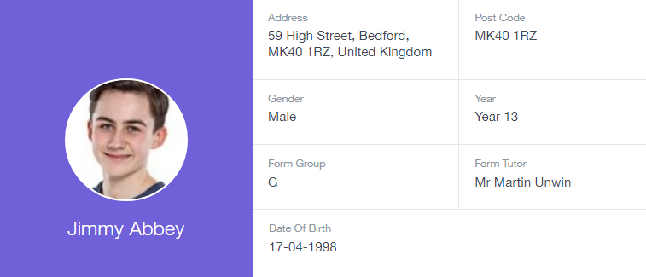

Next, choose the person to send your message to. As you can see in the example below it is broken down into teachers, form tutors, Head of Year and Head of House (this may differ between schools). Depending on who you want to send to, you can pick from the relevant boxes.
The default option is to pre-select all teachers. You can see this below as each teacher has a green tick beside. This means if you send a message now, it would go to all the selected teachers. To deselect specific teachers, just click on the green tick or deselect all using the smaller black tick. Click Next when done.

