St Nicholas Catholic High School
Year 6 to Year 7 Transition
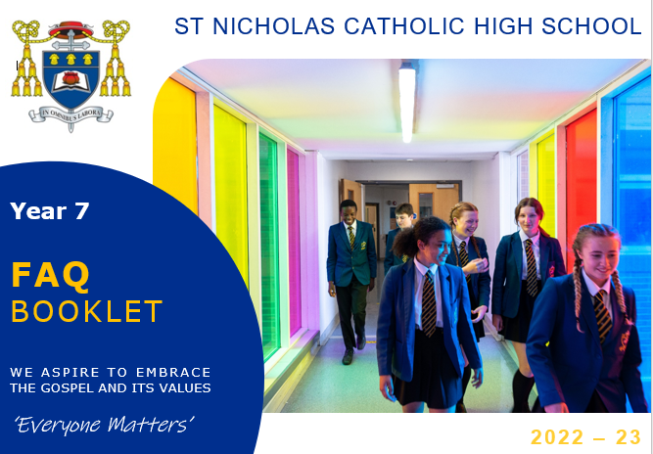

Frequently Asked Questions

Updated 6th June 2022

- How do I find out information about bus provision and times?
Current bus route and times are available on the school website at https://st-nicholas.cheshire.sch.uk/travel-details/

We will be sending all families a letter via email next week outlining further details – it will also include a link to an online platform where you can indicate which route you wish to access from September.

- How will relevant transition information about students be shared from Primary to Secondary schools should the school closures continue?

Our Transition Leader Miss L Jones will contact each Primary school and request that any relevant information is shared ahead of their start in September. This may require additional contact from a member of the SEND team to schools where there is an additional learning need of certain individuals. This will ensure that we can enable the best transition possible from Primary to Secondary education in September.

- How do you create the Form groups? Do you take Primary friendship groups into account and do students have the opportunity to request who they would like to be with?
The Form groups are currently in the process of being created and although I do not ask Primaries for friendship groups or ask students who they would like to be with, I do ask our Primary colleagues for their recommendations, if they have any, and I also ensure that they are with at least 1 other person from their school where feasible. Those students who are the only ones joining from their Primary school can be reassured that there will be others in your Form group that will be in the same position as you.

Students will spend the first 30 minutes of their day with their Form class; student's will have a Form Period for 7 out of 10 mornings. For the remaining 3 mornings, students will be engaging in Assemblies and Hymn Practice.
Students will then spend the majority of their day being taught in their teaching groups. They will be placed in a teaching group for Maths, Science, P.E and Technology and will be taught in the same teaching group for the remainder of their subject lessons. Students do not have their day to day lessons as a Form class.

How are sets formed in High school? What information do you use to create them?

Traditionally, Year 7 are taught in mixed ability teaching groups for all subjects except Maths. Usually, the setting for Maths is initially based primarily on SATs results.

How does the appointed form teacher information arrive?
A letter was sent home on Wednesday 24th June containing this information alongside a letter from their form Tutor and from their Year Leader Miss Hulme. You can request to find out who your form teacher is via the Transitions email address if you have still not received this information. If you have not received your letters by Friday 3rd July, please do let us know.

What is the average class size?
The average teaching class size is approximately 24 students whereas the average form class size is approximately 28 students.

Are there lockers available for Year 7 students?
There are enough lockers for all Year 7 student to have one. Year 7 are given priority for the locker in their first week. They will need to bring in a small padlock on their first day (we recommend a combination code rather than a key) and choose a locker to use. They then add their padlock to their locker and lock it.

Do we need to buy a white apron for technology?
You do not need to purchase an apron for Technology this year. Aprons will be provided for students.

Are Hockey boots and a gum shield required?
Gum shields are required for rugby and hockey.
Students only need trainers for hockey as we do it on the all-weather surface not grass.
Students only need boots with studs for any activities on grass for example football, rugby, fitness and cross-country.

Is there anywhere for the children to stay behind after school? And if so what is the latest time they are to be collected?
There is a homework club that is run until 4.15 every day after school and student who have work to complete are welcome to attend to complete their work. The latest that students can be collected from school is 4.15, unless they are attending a school fixtures/sporting even with school or a pre-arranged rehearsal for music or drama. In these instances, you will be advised in advance of the time that students will need to be collected.

Have Northern Rail delivered on their promise to provide a 4-carriage train home from Greenbank to Knutsford station?
I have contacted Northern Rail already and enquired as to their plans for September, particularly given current social distancing measures. They have not been able to confirm anything to me at this moment, but we will contact them again before the end of the Term and update this answer.

What stationery will students be required to have?
All students will require:
- Two pens
- A ruler
- A pencil
- An eraser
- A pencil sharpener
- Purple Pen
- Calculator
- Reading book

Due to the current circumstances we would also recommend that students have their own:

- Glue stick
- Colouring pencils
- Highlighters
- Geometry set

Students will also need to ensure they have the following equipment each day:

- School Planner
- Exercise books for lessons
- Lunch box/dinner card
- P.E kit for days when they have PE
- Bus/train tickets/passes/money
- Equipment/Ingredients for timetabled Technology lessons/ Musical instrument lesson etc.

What are the plans for the Transition visit days?
Students will be able to access taster lessons at St Nicholas. Their day will run from 9.30am to 2.30pm. Those students who do not attend one of our Partner Primary Schools (St, Wilfrid’s, St Mary’s, St Joseph’s, St Luke’s, St Bede’s, St Vincent’s) will need to make their own way to St Nicholas. They will not be able to use one of the School’s busses. Students can be dropped off for 9.30am and collected from 2.30 pm. Please see your information booklet for the dates of your child’s Transition day.
Students will need to bring their own snack and a drink for Break time; however, they have the choice to either bring their own packed lunch, or money for the canteen for their lunch. Please note, there is a maximum spend of £5 in a single day.

