POSITIVE MENTAL HEALTH WEEKLY CHALLENGE!

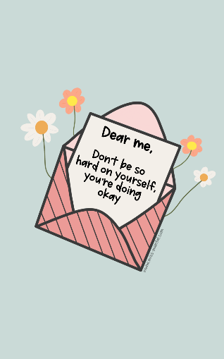
We all need to look after our mental health and the best way to do this is by doing something positive every day. This can be something small which helps you feel better. I have challenged you to take part in the activities below which are some of the things that I do to keep my own mental health positive. You should keep a photographic diary of evidence which will help your staff at Saint Nicholas learn all about you and the amazing things you do.
Miss Bown (English teacher and 7 Teresa form tutor).

CHALLENGE 1: Complete an intricate colouring sheet and take a photograph of it when it is completed.

CHALLENGE 2: Go for a walk to your favourite outdoor space (near you) and take pictures of five amazing things you find on your walk. Try to make them the best photographs that you could possibly take.

CHALLENGE 3: Complete your favourite activity away from a screen for 1 hour (or more!). This could be reading, cooking, running, walking, playing with your pet or many other options! Take a photo of your activity to add to your week of positive mental health activities.

