St Nicholas Catholic High School
Year 6 to Year 7 Transition
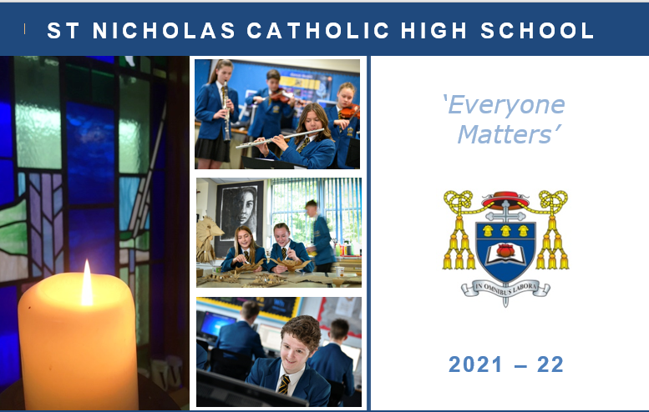

Frequently Asked Questions

Updated – 21st July 2021

- How do I find out information about bus provision and times?
Current bus route and times are available on the school website at https://st-nicholas.cheshire.sch.uk/travel-details/

- How will relevant transition information about students be shared from Primary to Secondary schools should the school closures continue?

Our Transition Leader Miss L Jones will contact each Primary school and request that any relevant information is shared ahead of their start in September. This may require additional contact from a member of the SEND team to schools where there is an additional learning need of certain individuals. This will ensure that we can enable the best transition possible from Primary to Secondary education in September.

- How do you create the Form groups? Do you take Primary friendship groups into account and do students have the opportunity to request who they would like to be with?
The Form groups have now been created and although I do not ask Primaries for friendship groups or ask students who they would like to be with, I do ask our Primary colleagues for their recommendations, if they have any, and I also ensure that they are with at least 1 other person from their school where feasible. Those students who are the only ones joining from their Primary school can be reassured that there will be others in your Form group that will be in the same position as you.

Students will spend the first 30 minutes of their day with their Form class; student's will have a Form Period for 7 out of 10 mornings. For the remaining 3 mornings, students will be engaging in Assemblies and Hymn Practice.
Students will then spend the majority of their day being taught in their teaching groups and will be taught in the same teaching group for the vast majority of their subject lessons. Students do not have their day to day lessons as a Form class.

How does the appointed form teacher information arrive?
A letter was sent home on Tuesday 29th June containing this information alongside a letter from their form Tutor and from their Year Leader Miss Hulme. You can request to find out who your form teacher is via the Transitions email address if you have still not received this information.

Will the school trip still be going ahead?
We are still planning and preparing for the Year 7 residential trip to go ahead; however, at this moment in time, all school residential trips are suspended. We will look to review as the government guidance changes and inform you straight away. We are hoping that it will go ahead!

What is the average class size?
The average teaching class size is approximately 24 students whereas the average form class size is approximately 28 students.

Are there lockers available for Year 7 students?
There are enough lockers for all Year 7 student to have one. Year 7 are given priority for the locker in their first week. They will need to bring in a small padlock on their first day (we recommend a combination code rather than a key) and choose a locker to use. They then add their padlock to their locker and lock it.

Do we need to buy a white apron for technology?
You do not need to purchase an apron for Technology this year. Aprons will be provided for students.

Are Hockey boots and a gum shield required?
Gum shields are required for rugby and hockey.
Students only need trainers for hockey as we do it on the all-weather surface not grass.
Students only need boots with studs for any activities on grass for example football, rugby, fitness and cross-country.

Is there anywhere for the children to stay behind after school? And if so what is the latest time they are to be collected?
There is a homework club that is run until 4.15 every day after school and students who have work to complete are welcome to attend to complete their work. The latest that students can be collected from school is 4.15, unless they are attending a school fixtures/sporting event with school or a pre-arranged rehearsal for music or drama. In these instances, you will be advised in advance of the time that students will need to be collected.

Have Northern Rail delivered on their promise to provide a 4-carriage train home from Greenbank to Knutsford station?
I have contacted Northern Rail already and enquired as to their plans for September, particularly given current social distancing measures. They have not been able to confirm anything to me at this moment, but we will contact them again before the end of the Term and update this answer.

What stationery will students be required to have?
All students will require:
- Two pens
- A ruler
- A pencil
- An eraser
- A pencil sharpener
- Purple Pen
- Calculator
- Reading book

Due to the current circumstances we would also recommend that students have their own:

- Glue stick
- Colouring pencils
- Highlighters
- Geometry set

Students will also need to ensure they have the following equipment each day:

- School Planner
- Exercise books for lessons
- Lunch box/dinner card
- P.E kit for days when they have PE
- Bus/train tickets/passes/money
- Equipment/Ingredients for timetabled Technology lessons/ Musical instrument lesson etc.

What is the first day for students in September?
All Year 7 students will start their high school journey with us on Friday 3rd September. This day has been dedicated to help students settle into high school and to provide the opportunity for them to familiarise themselves with St Nicholas. There will only be Year 7 and Year 12 students on site this day to allow us to commit to ensuring that our newest students have the best start possible to their High School journey.

Can students get on the bus on the first day without a pass?
As long as you have requested a place on the school bus, and this has been confirmed, there will be a space on the school bus for them. Do not worry about your bus pass in on the first day, simply get on the bus and you will get a temporary bus pass when you arrive at school. The Bus driver will know that our newest students will not have their bus passes yet.

When do students get their catering cards?
Students will receive their catering cards on their first day with us. Money can be uploaded to your child’s catering card via parent pay ahead of September 3rd to ensure they have funds available for their break and lunch time.
When will students get their timetable and find out who their teachers are?
Students will receive their timetable on their first day and this will list their teachers too. All Year 7 students should now know who their Form Teacher is for September.

