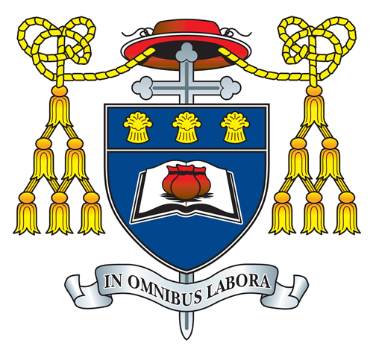

Name………………………………………………………………………..
Form……………………………………………………………………....
Primary School………………………………………………………

Welcome to your St Nicholas Catholic High school Transition booklet!

Throughout this booklet, there are lots of activities for you to try to help you feel ready and prepared for starting with us in September 2021. Your task is to complete as many as you can. Try and think carefully about your thoughts and feeling about leaving Primary school and starting Secondary. Just remember this - you are not the only one feeling this way!

As well as activities, there is lots of information about St Nicholas Catholic High School. This will help you to feel that you know all that you need to know before joining our community.

Are you ready to join our St Nicholas Family?

Let’s Go!

At St Nicholas we follow the 4Rs.

Have a read of our 4Rs below and see if you can make a coulourful mind map to help you to remember them.

2021 Time Capsule
Your time capsule can be like a frozen snapshot of time. You should re-read this time capsule in 7 years time, in 2028, when your secondary school journey at St Nicholas Catholic High School will be complete. You will be 18 years old, you will have completed your GCSE and A-Level examinations and will be able to look back on your 11-year old self at the start of this new and exciting journey. You will be able to look back at your life and experiences in 2021 and see how your life and the world has changed since then.

Name.............................................................................
Best Friend:……………………………….. Future job:………………………………………..

Hobbies:…………………………………………………………………………………………………………………………………………………………………………………………………………………………………………………………………………
Favourite Song:……………………………………………………………………………………………………………...
……………………………………………………………………………………………………………………………………………
In the News, today:………………………………………………………………………………………………………
……………………………………………………………………………………………………………………………………………
I spend most of my time:……………………………………………………………………………………………..
……………………………………………………………………………………………………………………………………………
The best thing about Primary School:………………………………………………………………………
……………………………………………………………………………………………………………………………………………
What am I most nervous about going to Secondary School:………………………………..
……………………………………………………………………………………………………………………………………………
What am I most excited about going to Secondary School:…………………………………
……………………………………………………………………………………………………………………………………………
I predict that by 2028… ………………………………………………………………………………………………
……………………………………………………………………………………………………………………………………………

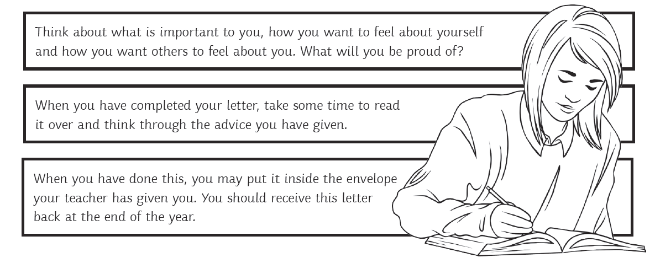
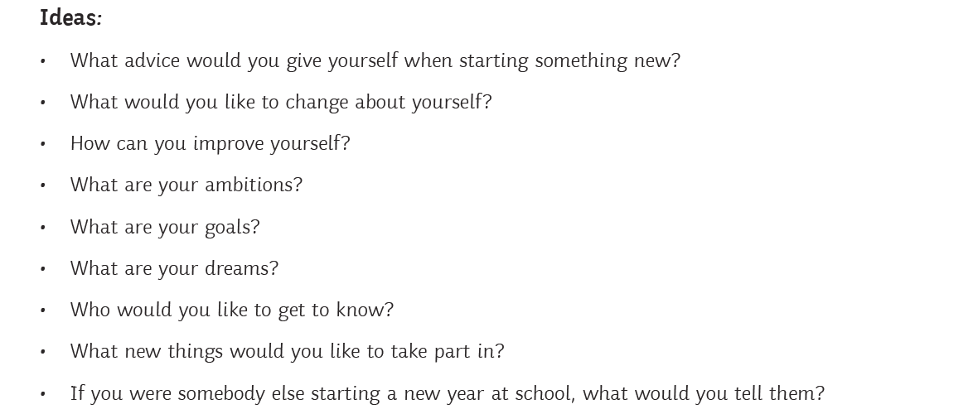

True or False
The St Nicholas Way
Its is very true that we have high expectations of our students at SNCHS and like every school there are key rules that we expect students to follow.
Have a look at the statements below and decide if you think they are True or False

Statement | True | False
At St Nicholas all girls must wear the School skirt
You are allowed to have your mobile in school with you but it must stay switched off in your bag.
The older students are mean. Don’t get in their way, or ask them for help, they won’t help you!
If you wear a St Nicholas skirt, the length must be no more than three inches above the knee.
There are a lot of people in school who can help you if you feel worried or concerned about anything.
You can have Pizza and chips for your lunch every day! The pizza is the best!
Jewellery is not allowed to be worn in school. If you are caught wearing Jewellery, it will be confiscated and your name will be recorded.
Make up is allowed to be worn as long as it is natural looking.
Nail varnish and false nails are allowed as long as they look natural, like a French Manicure.
No hoodies are allowed in school at all. They must not be worn or seen on the school premises.
If I leave my school shoes somewhere, it is okay for me to wear my trainers to school for a short period of time.
If I forget my School Planner, I must visit student support to collect a day planner instead.
Year 7s are always allowed in for their lunch first. We can just walk through when we want to go and eat.
There is a one-way system that operates in some parts of the school and this must be followed at all times. It is for everyone’s safety!
If I get a break or lunch time detention, I can go and get some food before I turn up to it.
Teachers at St Nicholas are really strict and issue After School detentions all of the time! Even on a Friday!
I can choose which homework I want to do and leave all of the rest.
I don’t have to record my homework in my planner as I can just look on Ruler. The teacher will remind us too!

Design a School Badge
Date Name
Think about…
Colour Symbols Words/Motto
What images could you include and why?

I think the school badge should look like this because:

Now, design a new school badge that reflects these important ideas:

Name of School:
Motto/Values:
Expectations:
L.O. To consider the aims and expectations of my new school.
Here at St Nicholas Catholic High School we have high expectations of staff and students (YOU!), and encourage you to participate in school life. Use this activity to help you reflect on the values of our school.

Diary
Write a diary entry about your final day in Year 6 and your feelings about starting at St Nicholas Catholic High School in September. What things are you looking forward to and what things are you going to miss?

Letter to my Form Tutor

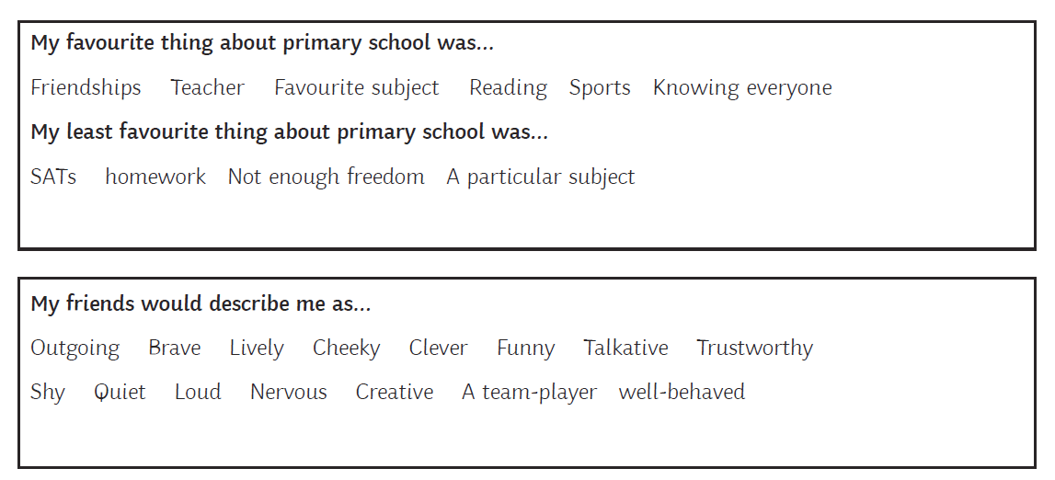

Below you can write down anything else that you would like to find out and/or questions that you would like to ask
Surviving Secondary School

Top Tips!
Be Prepared
Look at your timetable and make sure you know where to go and when.
Make sure you have the right books and equipment with you for each lesson.
Be Organised
Be Enthusiastic
Teachers won’t expect you to get every answer right, but they will be impressed if you try your best and ‘have a go’ at learning new things.
Be Resilient
Sometimes things won’t go your way. This is normal and happens to everyone, so don’t worry. Just say to yourself,
‘tomorrow’s another day!’
Be Brave
It might seem hard to make new friends, but everyone is feeling the same way. Say hello!
Be Kind
If someone else seems to be having a hard time, try to help. This is a good way to make friends and hopefully they will return the favour.
Be Yourself
Believe in yourself!
You can do it!
Be Honest
If you do something wrong or forget something, it’s much better to own up straight away.

School-Ready Checklist

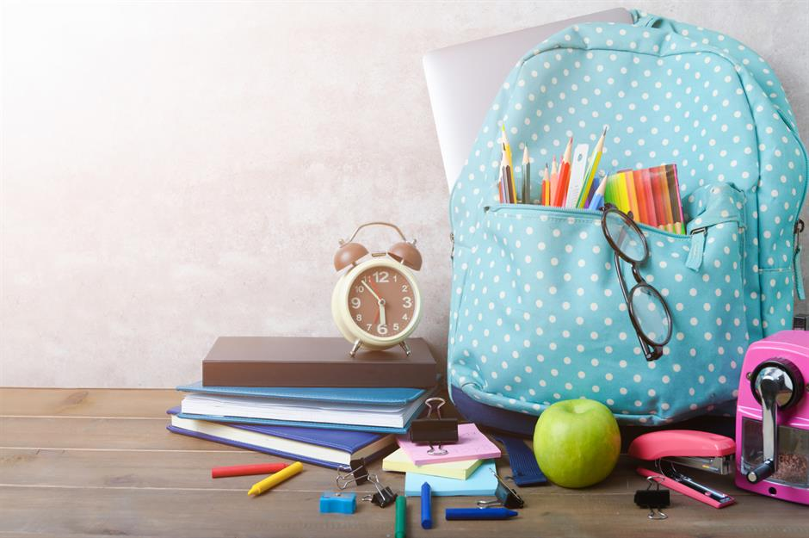

For school each day I need:
☐ school bag
☐ pencil case
☐ colouring pencils / felt-tip pens
☐ calculator
☐ school planner
☐ lunchbox or dinner money/card
☐ water in a clear bottle
☐ reading book/Library books
☐ P.E. kit on timetables P.E. Days
☐ Bus/Train ticket/money
☐ Any other equipment (food technology, instruments etc.)

Prayer
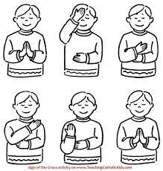
In school we have a number of prayers that we say very often. They are prayers said by all of the Catholic Church and join us in community with our parishes and people across the world.
We begin and end each set of prayers with the Sign of the Cross;
In the name of the Father, and of the Son, and of the Holy Spirit. Amen

The ‘Eternal Rest’ is a prayer for people who have died and is a lovely prayer for when you don’t know what else to say.
Eternal Rest grant unto them O Lord and let perpetual light shine upon them. May they rest in peace. Amen
The ‘Glory Be’ used to always be said with the Sign of the Cross but now is a short prayer of blessing;
Glory be to the Father, the Son
and the Holy Spirit.
As it was in the beginning is now, and ever shall be,
world without end.
Amen

The ‘Hail Mary’ is a prayer asking Mary, the Mother of God to pray with us;
Hail Mary full of Grace,
the Lord is with thee.
Blessed are thou amongst women
and blessed is the fruit of thy womb Jesus.
Holy Mary Mother of God,
pray for us sinners now
and at the hour of our death
Amen.
The Lord’s Prayer or ‘Our Father’ is a prayer that Jesus taught his friends;
Our Father, Who art in heaven,
hallowed be Thy Name.
Thy Kingdom come.
Thy will be done
on earth, as it is in heaven.
Give us this day our daily bread.
And forgive us our trespasses,
as we forgive those that trespass
against us.
And lead us not into temptation,
but deliver us from evil.
Amen

(Amen means ‘yes, we believe’)

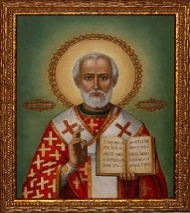
St Nicholas- Patron saint of children and students. Because of the many miracles attributed to his intercession, he is also known as Nicholas the Wonderworker and is one of the most well-known and well-loved saints in the world. Our form classes are also named after people of faith who have made a difference in the world.
St Bernadette of Lourdes became a symbol of commitment to the sick and disabled. Millions of people go on pilgrimage to Lourdes each year. | 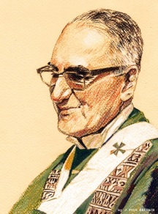  St Oscar Romero Archbishop of San Salvador, was shot dead while saying Mass because he challenged his government to deal with poverty and inequality.
Dom Helder Camara Brazilian Archbishop who said that caring for those in need was everyone’s responsibility. | St Teresa of Calcutta Founder of the Daughters of Charity, they care for anyone who is excluded or in need.
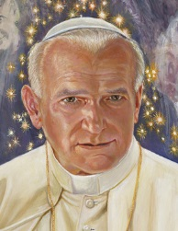  St John Paul II inspired the people of Eastern Europe, encouraged the young in their faith and is the most travelled pope ever. | 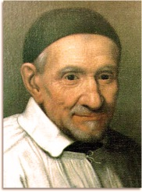  St Vincent de Paul - Priest who devoted himself to caring for people living in poverty and those who were alone. He inspired the SVP who carry on his work today.
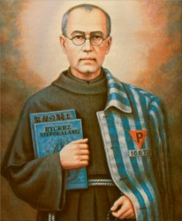  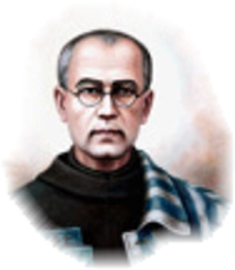  St Maximilian Kolbe was a Polish Franciscan, whose commitment to peace led to him volunteering to die in place of a stranger in Auschwitz. | 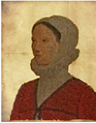  St Margaret Ward, English martyr born in nearby Congleton. Her commitment to her faith by helping a priest escape from prison became an inspiration.
Loving God, we thank You for the example of St. Nicholas, who fed the hungry, brought hope to the Imprisoned, gave comfort to the lost, and taught the truth to all. May we strive to imitate him by putting You first
in all we do. Give us the courage, love and strength of St. Nicholas, so that, like him, we may serve you through loving our brothers and sisters. Amen

Now, we have given you some information about our inspiring saints, why not choose one and see how much more you can find out for yourself? It might not be your form saint but there is a lot to learn from each of the saints.

Include a picture or drawing of the saint, some of their life history, when their feast day is, what they are best known for and why you have chosen them.

Sacred Space
Each morning, during form time, we have 5 minutes of Sacred Space which gives us an opportunity to pray together. Students help to lead the prayer which can be for something personal or for things that are going on in the world. It’s good to know that everyone in school is praying at the same time.
Now can you think of a way to pray that you might be able to bring into school for your form class?
Listen with God – instead of asking God for what you want. Give God a chance to speak to you about how much God loves and cares for you. Take a few minutes of silence every day to let God in.
Letting go of worry prayer – find a stone and hold it in your hand as you think about what is worrying you. As the stone warms up imagine your worry soaking away. When you are ready, bury the stone in your garden and ask God to fill you with light and grace instead.
Choose a song that explains how you feel and use that as a starter for a prayer, speaking to God about how you feel at this time.
Decorate a jar and add strips of paper with people and situations that need prayers. Every day pick one out and pray about it. Add more prayers when needed.

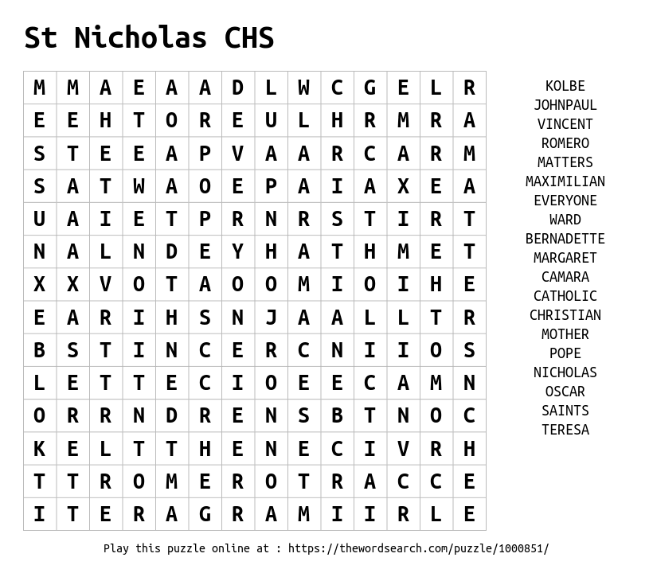
Try our St Nicholas and Form Saints Wordsearch and then see how beautifully you can colour our saint ‘icon’ (holy picture).

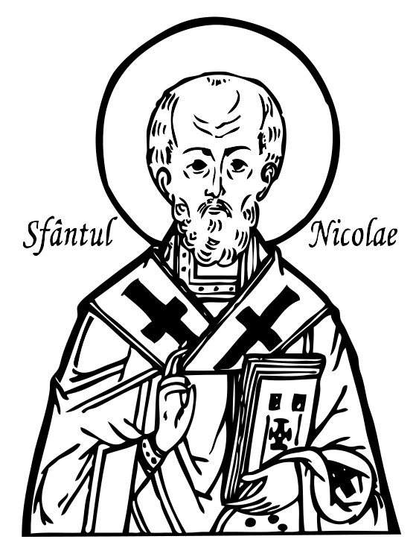

True or False
The St Nicholas Way - Answers
Its is very true that we have high expectations of our students at SNCHS and like every school there are key rules that we expect students to follow.
Have a look at the statements below and decide if you think they are True or False
Statement | True | False
At St Nicholas all girls must wear the School skirt  You can choose if you want to wear either the School skirt or trousers. |  | X
You are allowed to have your mobile in school with you but it must stay switched off in your bag.  Definitely not! No mobile phones are allowed in school. They are classed as a banned item- as are chewing gum and any type of energy drink! If you MUST bring your mobile into school, it must be handed in to student support at 8.30 every morning. You can then collect it at the end of the day. If you are caught with a mobile phone it will be confiscated, your parents/carers will be contacted and you will be sanctioned. |  | X
The older students are mean. Don’t get in their way, or ask them for help, they won’t help you!  Nope! Another big false one. Our students are very friendly and helpful. They offer to help students find their way, be student mentors and want to help in any way they can! Honestly. You will soon see! |  | X
If you wear a St Nicholas skirt, the length must be no more than three inches above the knee.  Absolutely yes! When your skirt becomes too short, you will be required to purchase a new one . | X
There are a lot of people in school who can help you if you feel worried or concerned about anything.  Yes! We have a fantastic Pastoral team at SNCHS. You have your Form Tutor, who can help you- you will see them every single day! You will have your Year Leader who can help you, and we have our Learning Mentors too! You can go to any lunch time ‘drop-in’ session and speak to them if you are feeling worried or concerned about anything. They are there to help you every single day! | X
You can have Pizza and chips for your lunch every day! The pizza is the best!  I’m sorry, but no, this is not true! We have fish and chips on a Friday though. We are a Heathy Eating school and there are a wide range of choices that you can choose from every day, from Sandwiches, to pasta and jacket potatoes, and a choice of main meal on the main counter. Every Wednesday you can get a Roast Dinner! |  | X
Jewellery is not allowed to be worn in school. If you are caught wearing Jewellery, it will be confiscated and your name will be recorded.  There are no exceptions to this rule. No-Jewellery at all is allowed. If you want to get you ears pierced, do it at the start of the Summer Holidays, that way they can be removed before you start back in September! | X
Make up is allowed to be worn as long as it is natural looking.  Another no. No make at all is allowed to be worn in school. If you are seen to be wearing make-up you will be sent to remove it and a sanction will be issued. |  | X
Nail varnish and false nails are allowed as long as they look natural, like a French Manicure.  Again, no… No false nails or nail varnish of any kind can be worn in school. You will be asked to remove it and issued with a sanction if you do wear it. If it cannot be removed immediately, you will spend all of your break and lunch times with your Year Leader until it has been removed! |  | X

True or False
The St Nicholas Way - Answers Continued
Its is very true that we have high expectations of our students at SNCHS and like every school there are key rules that we expect students to follow.
Have a look at the statements below and decide if you think they are True or False
Statement | True | False
No hoodies are allowed in school at all. They must not be worn or seen on the school premises.  Yep! These will be confiscated if seen on the School site! Also, no coats are allowed to be worn indoors. As soon as you enter the school building, coats need to be removed. | X
If I leave my school shoes somewhere, it is okay for me to wear my trainers to school for a short period of time.  You must wear the correct footwear. No type of trainer are allowed to be worn as a school shoe! If you are wearing trainers, you will spend your break and lunchtimes with your Year Leader until you have the appropriate footwear. |  | X
If I forget my School Planner, I must visit student support to collect a day planner instead.  It is that simple- we are all human; we all make mistakes. We just have to be more organised in the future. Speak to your Form Tutor who can help you with this if you struggle with your organisation. | X
Year 7s are always allowed in for their lunch first. We can just walk through when we want to go and eat.  Sorry Y11 only. The dinner queue works on a rota system, one week Y7 will be fist in the queue, then Y8, Y9,Y10… the next week will be Y8, Y9, Y10, Y7.. etc. |  | X
There is a one-way system that operates in some parts of the school and this must be followed at all times. It is for everyone’s safety!  You will be shown the one way system and the right way to use it in your first days at SNCHS- Check out the Virtual Tour that will be appearing on the school’s website too! | X
If I get a break or lunch time detention, I can go and get some food before I turn up to it.  You must go straight to your detention! Your Teacher will ensure that you are able to get some lunch before your next lesson and will tell you when you can go. |  | X
Teachers at St Nicholas are really strict and issue After School detentions all of the time! Even on a Friday!  Follow and respect the 4Rs and you do not even need to worry about this point. Teachers at SNCHS are fair and will help you to make the right choices. |  | X
I can choose which homework I want to do and leave all of the rest.  You are expected to complete all the homework that you are set! If you have an issue or do not understand something about your homework, speak to your teacher in plenty of time so that you do not miss your homework deadline! |  | X
I don’t have to record my homework in my planner as I can just look on Ruler. The teacher will remind us too!  You are expected to record all of your homework in your school planner AND check on Ruler too! It is not the Teachers’ responsibility to remind you that you have homework. It is yours! |  | X

