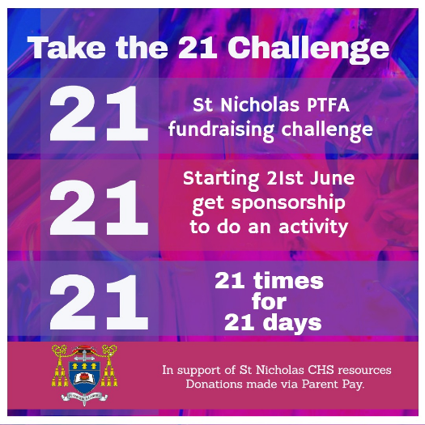
NAME
MY 21 CHALLENGE

ON MY OWN OR WITH A FRIEND?

NAME | AMOUNT | PAID

When you have collected funds ask a parent to send this to school via ParentPay
Thank you for supporting your school!

