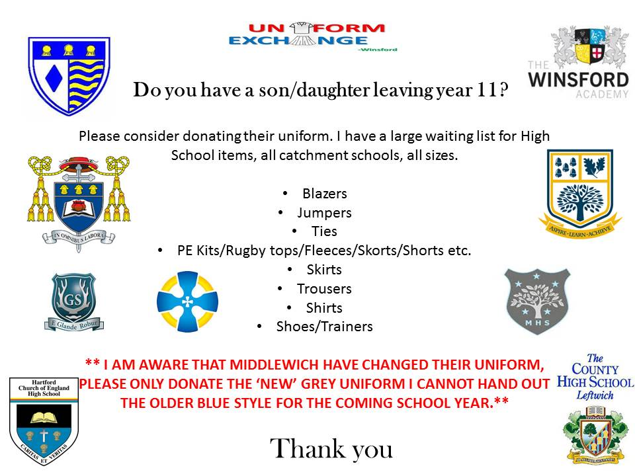

The PTFA are supporting Uniform Exchange in Winsford who collect good quality pre-loved/unused uniforms for all catchment schools in the local area, from Nurseries to Secondary Schools.

There is an increased demand for help with school uniforms due to the impact of Covid-19. Uniform Exchange collect logo uniform, general uniform, shoes, trainers, bags, PE kits etc and give these out to anybody who needs them for free within the local community.

They are based upstairs in the old job centre building on the High Street, above Winsford Community Grocery and they open Mondays and Thursdays 9.30-12 noon for people to call in an collect any uniform required. There is no referral required and no payment necessary. Emma Ball who runs the exchange is always available to contact via messenger/Wattsapp/website for requests for uniform. Her mobile is: 07845783598

If you have any unused/surplus items of uniform that you are happy to donate that would be wonderful and Emma is more than happy to collect.

Thank you very much.
https://www.facebook.com/uniformexchangewinsford

www.uniformexchangewinsford.co.uk

