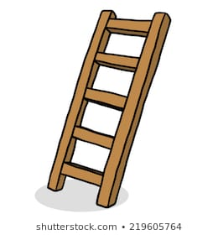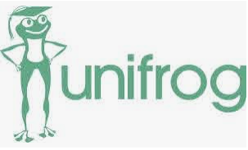

October 2020

Register on Unifrog – if not done in Y7

28th Jan 2021

Employer encounter

1st July 2020

Dispelling myths

**Where can I get more information?**

Mrs Stobbs

**What is Unifrog?**

In Year 7 you will receive a username and password for Unifrog. You need to keep logging your careers experiences in Year 8.

**Dates for your diary…..**

**What is Start?**

Start Profile will help you to look at careers and start to think about what you need to get there.

What support can we expect in Year 8 regarding careers and what we want to do next?