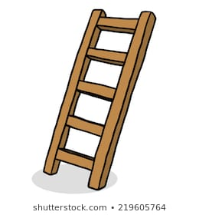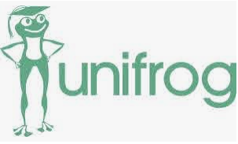

**Where can I get more information?**

Mrs Stobbs

**What is Unifrog?**

In Year 7 you will receive a username and password for Unifrog. You will use Unifrog until you are 18. It helps you to look at careers and track experiences you have which will help in the future.

**Dates for your diary…..**

October 2020

Register on Unifrog

28th Jan 2021

Start Profile Intro.

1st July 20201

Employer encounters

**What is Start?**

Start Profile will help you to look at careers and start to think about what you need to get there.

What support can we expect in Year 7 regarding careers and what we want to do next?