8 January 2020
Update on GCSE and A-Level Examinations 2021

Dear Parents and Carers
This week in Parliament, the Education Secretary outlined the following arrangements for all schools in England:
“I can confirm that GCSEs and A and AS Level exams will not go ahead this summer. This year we are going to put our trust in teachers rather than algorithms.
The department and Ofqual had already worked up a range of contingency options. While the details will need to be fine-tuned in consultation with Ofqual, the exam boards and teaching representatives, I can confirm now that I wish to use a form of teacher-assessed grades, with training and support provided to ensure these are awarded fairly and consistently.”
After this announcement on Wednesday, and the confirmation that qualifications will now move to ‘teacher-assessed grades’, there will now be a formal consultation beginning on Monday 18th January. This will be co-ordinated by The Office of Qualifications and Examinations Regulation which regulates qualifications, examinations and assessments in England – Ofqual.
The current advice from Ofqual is outlined below, and is advice that we fully support:
“We know that this is a difficult time for students, their parents and carers, teachers and trainers. Our message to students is this: please continue to engage as fully as you can in your education. That will be online for the majority of students, or face-to-face for those students still going in to their school, college or training provider. This will put you in the best position, whatever arrangements are made for your qualifications. It’s important that teachers and students can focus on the knowledge and skills needed to equip students to progress to the next stage, whatever form that might take – whether to college, an apprenticeship, university or employment.”
Once we receive further guidance, advice and details we will of course write to you with full information.
In the interim, the school has taken the decision that Year 13 Mock Examinations remain postponed pending further guidance from Ofqual on the assessment processes they intend to use this year. Once this information has been provided, we can then offer a fully informed response and ensure that each and every student at St Nicholas Catholic High School is fully supported to achieve of their very best.

Finally my message to all students was absolutely clear during assembly yesterday. They must continue to seize every opportunity in lesson, completing homework, conducting research tasks and through independent study to demonstrate to their teachers on a regular basis the knowledge and skills they have. I also offered reassurance that we will do all that we can to ensure that students will be supported throughout to secure the next phase of their lives wherever that may be.
I hope this letter goes someway to offer both clarity and reassurance at this once again unprecedented juncture.
Yours sincerely
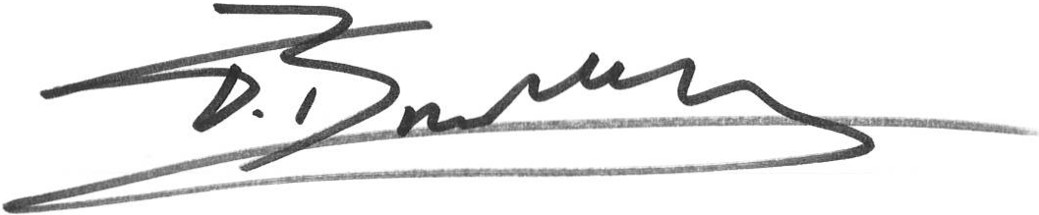
Mr T Bradley
Director of Sixth Form

