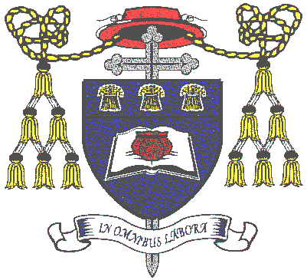

Privacy Notice: Local Authority Covid-19 Recovery Programme

In order to understand the impact of COVID-19 and lockdowns on students, St Nicholas Catholic High school are involved in a project with Cheshire West and Chester Council and Social Finance Limited to analyse patterns of attendance and behaviour amongst pupils in an effort to understand the impact of possible future lockdowns. This will allow the Council to:

- identify the pupils who are likely to have increased needs and vulnerabilities when returning to school after lockdown;
- understanding the level of support needed and informing the targeting of interventions post lockdown;
- supporting Local Authority to best allocate budgets to support the pupils currently most in-need or at-risk of having significant increased need in the future;
- Building resilience and informing any potential future lockdown strategies.

What personal data is being processed?
The information being provided is generally supplied to the Council as part of the school census, but for this initiative contains details specific to the lockdown period.
- Name
- Date of birth
- Unique Pupil Number (UPN)
- Postcode
- Student’s attendance both pre and post lockdown.
- Student’s attendance during lockdown.
- Details of exclusions – reason, date of exclusion, number of excluded sessions
The information provided to the Council will be pseudonymised and individual students will not be identified.

What is your lawful basis for processing this personal data?
The legal basis for sharing this data with the Council is under Article 6(1)(e) in that it is necessary for the performance of a task carried out in the public interest or in the exercise of official authority vested in the controller.

How long will my personal data be retained by the Council?
The Council will only keep your information for as long as it necessary to complete their analysis and all data will be pseudonymised to ensure individual students cannot be identified. All data will be deleted at the end of the processing, which will conclude at the end of the project in March 2021 and data will be securely deleted.

Your rights

If you are not happy about the way your personal data is being processed you can complain directly to the school’s Data Protection Officer by email:
gdpr@imperosoftware.com
You also have the right to complain to the Information Commissioner’s Office.
- Website: Information Commissioner's Office (ICO) website
- By post: The Information Commissioner's Office, Wycliffe House, Water Lane, Wilmslow, Cheshire, SK9 5AF
- Telephone: 08456 30 60 60 or 01625 54 57 45
If you require further information about how we process your personal data, you can contact the Data Protection Officer via: gdpr@imperosoftware.com

