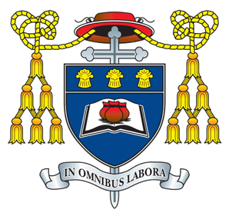
FAQs- Year 11 Information Evening

- Will my child sit their exams next year?

Ofqual have announced that at this current time the plan is for all students to sit their exams as normal next year.

- What is happening with mocks?

Students will sit their mock examinations from the 9th November. Further details regarding this will be sent out by Mrs Pardoe in a letter.

- Will my child have to learn the same content as before?

Ofqual carried out a consultation and there are some minor changes to course content for some subjects, this will be communicated to the students through the subject teacher and it will be clear what students need to revise.

- My student has missed four months of schooling will they be ready to sit their exams.

Work was set during lockdown that was in line with the Year 10 curriculum. This work was left online over the summer and this was communicated to students during the final assembly in July. In every subject the students are currently undertaking bridging units to ensure they are fully prepared to sit their exams next summer. Details of these bridging units can be found in the back of student exercise books and details will also be made available on our school website.

- Where can I access past papers?

Your child’s subject teacher will complete past paper questions in lessons and will make past papers available to pupils or show them how to access papers from the exam board website. As the syllabuses are still rather new there are only a couple of years of past papers to refer too.

