Dear Parents, Carers and Students,

Once again, welcome to the St Nicholas Catholic High School Community!

I know that things have been a little different this year and that is why there is a new, specially designed Transition Programme just for you, as you move from Year 6 to Year 7.

In the Welcome booklet you have already received, I outlined a few of the activities that I have planned for you and you have been sent a number of different letters and forms to be completed and explored. So far you should have received the following:

Posted on 7th April
Welcome booklet & letter from Mr Woods (Headteacher) plus a letter on pink paper containing ‘Parent Pay’ login details.

Email on 23rd April
Letter A - Transport - All parents/carers will need to complete the on line form by 31st May
Letter C - Music Tuition - on line form to be completed by 31st May only if required
Letter D - Residential Information - All parents to pay first instalment of £30 by 7th August together with ticking the consent box on Parent Pay. You will need to register with Parent Pay first before you will be able to do this.

Email on 14th May
Admissions Information Form - all parents/carers will need to complete the on line form by 31st May

Please let us know if you are missing any of the communications listed above via transitions@st-nicholas.cheshire.sch.uk.

Attached to this letter there is an outline and timetable of activities that you will be receiving over the coming weeks and some ongoing ‘challenges’ to keep you busy so you’re ready to join St Nicholas in the near future. I hope that you enjoy learning all about our community and the people that make it such a special place to learn. Any challenge entries or questions that you would like to submit can be sent to transitions@st-nicholas.cheshire.sch.uk.

I have also included in this pack the first of your transition events; I have created a Transition Activity booklet for you to complete at home. This booklet will help you to prepare for starting with us at St Nicholas Catholic High School and it has been designed to help you all to feel ready to begin your new secondary school adventure.

We are finalising school uniform arrangements and we will write to you after the Half-Term break with full details regarding ordering and collection.

If you have any further questions, please do not hesitate to get in touch.
I cannot wait to welcome you all to the St Nicholas Catholic High School community in person.

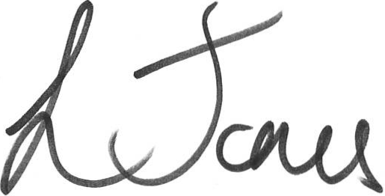
Kind regards,

Miss Jones
Transition Leader

