Examination Update from Ofqual – 26.3.20

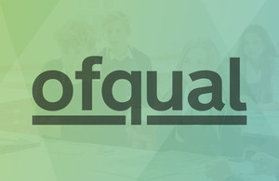
We are rapidly working up plans to implement the arrangements the Secretary of State for Education has set out for exams this summer and, with exam boards and teaching bodies, are making considerable progress.
Students understandably want reassurance, and teachers urgently need to know what to do, and when. We expect to publish detailed information about the process and timetable which will apply this summer next week. This will include the steps we would like teachers to follow and more detailed guidance on how to consider the full range of evidence they will have available when submitting their assessment grades. We are talking to teaching representatives to make sure that what we are planning is manageable and appropriate, so that students, parents, carers and teachers can have confidence in the approach.
We will outline by Easter the process we will follow to make sure grades are fair across schools and colleges, as well as our proposals for appeals. We will also say more as soon as possible about the arrangements for additional exams in the new academic year.
We want to reassure students waiting for news that we are doing everything we can to make sure they are not disadvantaged by these unprecedented circumstances.

