19th March 2020

Dear Parents and Carers

St Nicholas Catholic High School – School Closure

Following the announcement by the Prime Minister yesterday, we write to inform you that St Nicholas Catholic High School will be closed to students from Monday 23rd March until further notice.
We do not underestimate the significant burden that this will place on families at this uncertain time, and the difficulties it will present for all our students. We want to assure you that over the last few days staff at school have worked tirelessly to secure alternative arrangements for students to work from home

Home Learning
To support your child’s ongoing learning we have implemented the following measures:
- Work will be set by staff each week using the school’s online learning platform – Ruler
- Work for each subject in each year group will be uploaded to Ruler by 10am on the Monday of each new week.
- Work will be provided for the week ahead, with resources and tasks signposted in each subject.
- We have provided an individual ‘Student Log’ on Ruler so that students can keep a log of their own learning for you to support and monitor.
- Staff will not be requiring students to return specified pieces of work for marking or feedback.
- Should students in Years 10, 11, 12 and 13 wish to send work to staff for comment or feedback then this should be done via their school office 365 email account.

- We are asking staff to monitor their emails remotely from home on a daily basis, but we ask for your patience as staff look to balance their professional responsibilities alongside their own personal health and that of their dependants.
- For those students who do not have access to Ruler, we have provided individual ‘Work Packs’ which will be available for collection tomorrow.

Forgotten Passwords
If a parent, carer or student forgets their password for Office or Ruler they should send an email to: forgotten@st-nicholas.cheshire.sch.uk requesting a password reset. Our Technician will be monitoring this inbox on a daily basis and will respond as soon as possible. If the password reset is requested by a parent or carer then they need to include the student’s username in the request.
Additional Resources
We have provided a list of available websites and e-resources to support your child’s wider learning – these accompany this letter.
Examinations
As we write this letter, the Education Secretary Gavin Williamson has announced that “we will not go ahead with assessments or exams, and that we will not be publishing performance tables for this academic year. We will work with a sector and have to ensure children get the qualifications that they need.” School have not as yet been given the details behind this statement in relation to Sixth Form applications and University admissions.
We will continue to update you via the COVID-19 information page on our school website and Parentpay communications as details are provided.
Pastoral Care and Support
We have provided a range of activities, advice and guidance on emotional wellbeing on our school website and our School Chaplain, Mairie, will offer ongoing reflections and prayers via our school Twitter feed.

Questions and Queries
Understandably, you may have questions and concerns that arise as we respond to this ongoing situation together. In the first instance, I would politely request that you access official Government sources of information via the website: www.gov.uk. Additionally, we will continue to post responses to Frequently Asked Questions on the school website Covid-19 page.
Should you then require further clarification, I would ask that you use the following email addresses in the first instance:
- Examination Information – please note, as I am sure you will appreciate, we will be unable to specify any further information until arrangements are confirmed by the Department of Education. Mr Spencer: s.spencer@st-nicholas.cheshire.sch.uk.

- Subject Specific questions in relation to work set – please email your child’s class teacher directly. Given the unprecedented situation we all find ourselves in, I am sure you will appreciate that unfortunately we cannot guarantee a response as outlined in 6 above, but will endeavour to do so.

- All other questions and concerns should be sent to admin@st-nicholas.cheshire.sch.uk. This email address will be monitored daily and your email forwarded to the most appropriate staff member available. We ask for your patience and understanding as questions are triaged and managed as best we can given unknown staff availability.
We will continue to post responses to Frequently Asked Questions on the school website Covid-19 Page.

Safeguarding
If you have any concerns during this period of school closure then please follow relevant guidance on the School Website under ‘what to do if you have concerns about a child’ https://st-nicholas.cheshire.sch.uk/safeguarding/#1512142110128-d6b6edb8-9bc9

Schools Open for the children of ‘Key Workers’ and ‘Vulnerable Children’
The Prime Minister also announced last night that “we therefore need schools to make provision for the children of [these] key workers who would otherwise be forced to stay home. And they will also need to look after the most vulnerable children.
Schools have not yet been given any details in relation to this statement but we will update you as soon as clear guidance has been given and necessary arrangements have been put in place.

Next Steps Together
You can be assured that the Senior Leadership Team will remain in regular communication with each other, Subject Leaders, Pastoral Leaders and Support Staff during the weeks ahead. We have established clear ‘behind the scenes’ methods of communication to ensure that we can receive, discuss and respond to information, requests and suggestions as they arise. We will continue to use Parentpay, Twitter and our School Website to keep you updated on a regular basis.
These are unprecedented times and we enter them together as members of the one St Nicholas community and family - students, parents, carers, staff and governors.
We thank you, as always, for the continued support you offer to the St Nicholas community.
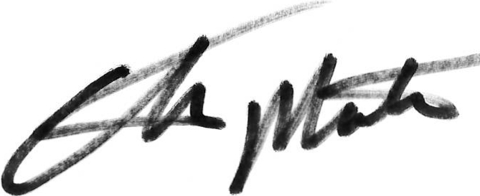
Yours sincerely
Richard Woods Chris Mottram
Headteacher Chair of Governors

