Learning away from the classroom
KS3
Where | What | How
 | All subjects with various activities and online learning videos | https://www.bbc.co.uk/bitesize
 | Various quizzes | https://www.senecalearning.com/
 | Online research about any curriculum area | https://www.youtube.com/

KS4 & KS5
Where | What | How
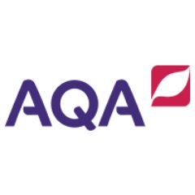 | Past paper questions & mark schemes | https://www.aqa.org.uk/
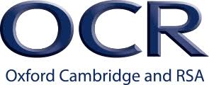 | Past paper questions & mark schemes | https://www.ocr.org.uk/
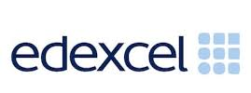 | Past paper questions & mark schemes | https://qualifications.pearson.com/en/home.html
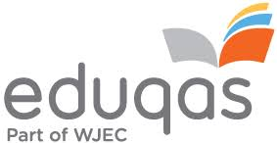 | Past paper questions & mark schemes | https://www.eduqas.co.uk/
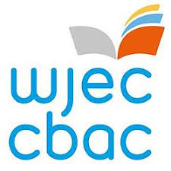 | Past paper questions & mark schemes | https://www.wjec.co.uk/
 | Various quizzes | https://www.senecalearning.com/
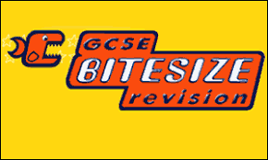 | Past paper questions & mark schemes | https://www.bbc.co.uk/bitesize/levels/z98jmp3
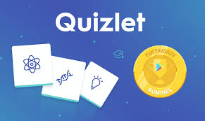 | Different quizzes | https://quizlet.com/en-gb
 | Online revision videos | https://www.youtube.com/
 | Revision App | http://www.gojimo.com/
 | Maths Revision | https://www.examsolutions.net/
 | Hegarty Maths | https://hegartymaths.com/
 | English Literature | https://www.sparknotes.com/
 | Mindfulness | https://www.headspace.com/
 | Extension tasks and further research via MOOC’s | https://www.unifrog.org/

Further GCSE revision guidance can be found in the revision booklet found on our school website below:
