It is very important that you do make this claim if you are entitled to it. Much more money is now allocated to the school on the basis of the number of children on free school meals. Therefore, you will be supporting the learning of children at St. Nicholas Catholic High School in more ways than you might think if you do claim this entitlement.

We liaise very closely with the bus companies to ensure we have sufficient transport arrangements in place, therefore I should be very grateful if you could indicate on the reply slip attached if you will require school transport.

Your response is appreciated as I have to re-negotiate the bus contracts during the Summer Term 2019 and numbers are vital for this process.

Yours sincerely

C Jones

Mrs C Jones
Finance Officer

……………………………………………………………………………………………………………………………………………………………..

SCHOOL BUS TRANSPORT
Applicants for St Nicholas Catholic High School September 2019

To: Mrs C Jones

I WILL require transport / I WILL NOT require transport (please indicate) & return by 24th May 2019

Relevant Bus Route ………………………………………………………………………………………………………………………..……

Bus Stop ………………………………………………………………………………………….…………………………………………………..

Signed ………………..……………….………………………………………... Date . …………………..…………..……………

Parent/Guardian of ………………………………………………………….………………………………………………………………...

Any other information re: transport (please indicate below):

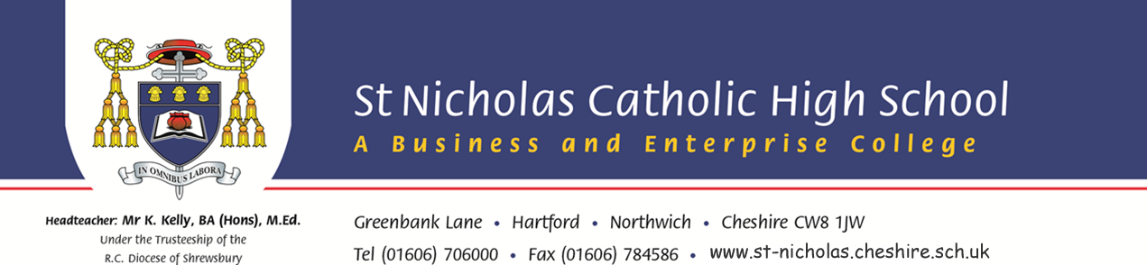
Headteacher: Mr R Woods, BA (Hons), PGCE, NPQH Greenbank Lane, Hartford, Northwich. Cheshire CW8 1JW
Under the Trusteeship of the Tel (01606) 706000 ~ Fax (01606) 784586 ~ www.st-nicholas.cheshire.sch.uk
RC Diocese of Shrewsbury

+
May 2019

Dear Parent/Carer

I am sure you will know that the provision of school transport no longer rests with schools and we rely on external companies to provide home to school transport.

Please refer to our website www.st-nicholas.cheshire.sch.uk and look on the Information tab where you will find a Travel details section which contains information about the current School Transport timetable. If there any changes we amend this information immediately. There is also information advising on routes for trains coming to and from Greenbank Station, which is less than half a mile from the school.

Four of the current bus routes (Winsford – Whitegate; Winsford – Wharton; Helsby; Holmes Chapel) are operated on a School Managed Service basis and tickets will need to be purchased in advance from School through ParentPay. Alternatively you can contact school to request a barcoded letter for payment via a Paypoint facility if you would prefer. Bus tickets for these routes cannot be purchased from the driver.

Individual Tickets
Individual single journey tickets can be purchased in books of 10 via ParentPay for any of these routes and collected from the Finance Office in advance of travel. These tickets are transferable and can be used on any journey, inward or homebound, on any day.

Termly Bus Pass
There will be a termly payment option (return or single) on ParentPay for each of these routes. Payments can be made in instalments during the term as long as the cost of travel up to each half term is paid in full before the end of that half term. Laminated bus passes will be issued during the first week of each term for students requiring the termly option. If a term pass is misplaced then a replacement will be issued on payment of £5 via ParentPay.

The Appleton and Knutsford bus routes are commercially operated by Walkers bus company and tickets for these routes will need to be purchased from the driver.

Local authorities are still obliged to provide free transport for students on free school meals. If you feel you qualify for free school transport, then contact the following depending on where you live:

www.cheshirewestandchester.gov.uk school transport link or telephone 0300 123 7039

www.cheshireeast.gov.uk school transport link or telephone 0300 123 5012

