

May 2019

Dear Parents and Carers

The Governing Body are pleased to inform you that a place has been reserved for your child at St Nicholas Catholic High School for the term beginning **Wednesday 4th September 2019.**

Leaving primary school and beginning secondary school is a big step and I assure you that we will do all we can to ensure that your child settles in quickly at St Nicholas’. In addition, we place great value upon good relations between yourselves and the school and to this end we are planning a New Intake **Parents’ Information Evening on** **Tuesday 25th June at 6.00pm.** This is an opportunity to find out more about the school, the curriculum, school uniform, procedures and standards.

Furthermore, please find enclosed with this letter the following correspondence:

* A Year 7 Welcome Booklet
* School Transport letter *(green paper)* – form to be returned by **Friday 24th May**
* Admission Information Form *(cream paper)* – to be returned in the envelope provided on your child’s **Induction Day** *(see page 3 of the Welcome Booklet for dates).*

Please ensure sections A, B, C and D are all completed and signed.

* Music Tuition letter *(yellow paper)* – form to be returned **as soon as possible**
* Year 7 Residential letter *(blue paper)* – form to be returned by **Friday 6th September**
* ParentPay letter *(white paper)* containing personalised login and password details
* PTFA Parent Questionnaire *(lilac paper)*
* Privacy Notice *(pink paper)*

I look forward to meeting you on 25th June.

Yours sincerely



Mr Richard Woods

Headteacher

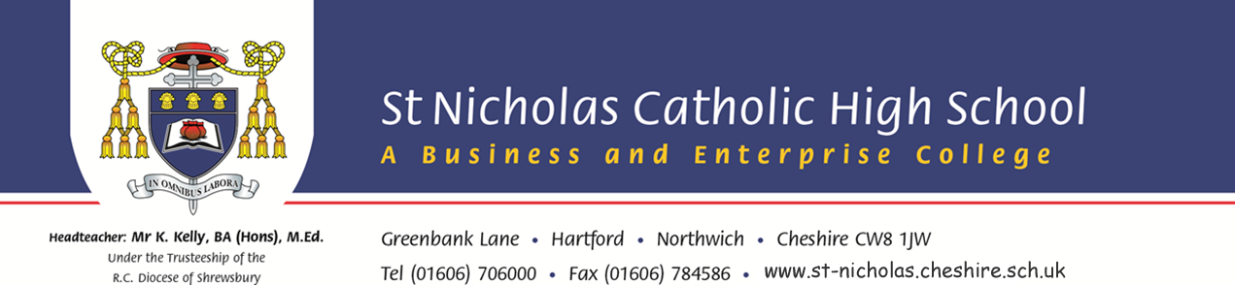

**Headteacher: Mr R Woods, BA (Hons), PGCE, NPQH** Greenbank Lane, Hartford, Northwich. Cheshire CW8 1JW

*Under the Trusteeship of the* Tel (01606) 706000 ~ Fax (01606) 784586 ~ www.st-nicholas.cheshire.sch.uk

*RC Diocese of Shrewsbury*

+