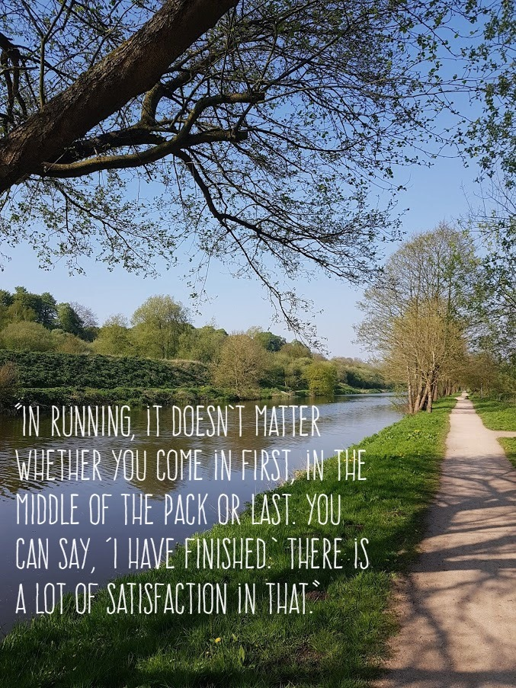
ST NICHOLAS RIVER RUN
Saturday 21st September 2019
Be in the running…
We are delighted to be hosting the St Nicholas River Run, a community festival of running which takes in our fantastic woodland trails, Marshall’s Arm Nature Reserve and River Weaver towpaths.
We would like to involve as many runners as possible, young and not so young, pupils, teachers, families and friends, in promoting mental and physical health through participation in one of the simplest exercises possible, running.
So, for those who have the running bug and for those who haven’t yet, these are the events for you to run, walk or jog:
10km trail run – a chip timed event for those 15 years and over
5km trail run – a chip timed event for those 11 years and over
2km family fun run - for everyone - please book on the day
There will be a bespoke blue bridge medal for finishers of the timed events and a fun run medal for the 2km event.
Experienced or not, get your trainers on and give it a go!
For more information and to book your place please click:
https://st-nicholas.niftyentries.com/St-Nicholas-River-Run-2019

