Year 8 Examinations

3th- 14th June 2019

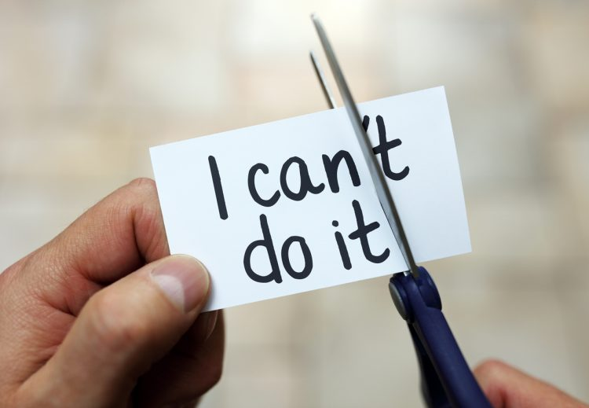

In this booklet you will find:

* Your examination timetable.
* Key tips on how to revise.
* Specific revision tips from your subject areas.
* Space to reflect on your examination results and set targets moving forward.

|  |  |  |  |  |  |  |
| --- | --- | --- | --- | --- | --- | --- |
| **Year 8 Exam Timetable - Week 1 Timetable 3th-7th June** | | | | | | |
|  | Monday 3rd | Tuesday 4th | Wednesday 5th | Thursday 6th | | Friday 7th |
| Lesson 1 | 8B4 COM– JB  8B3 RE – AA  8B2 RE – EE  8B1 RE - HP |  | 8Y2 ART - SG | 8Y2 RE – SH  8B4 HISTORY – GH  8Y3 DRAMA - JFH | |  |
| Lesson 2 | 8U4 HISTORY – GH  8Y3 ART – KMc  8Y1 RE - DF | 8Y2 ENG – NG  8Y2 ENG – NW  8Y2 DRAMA -SL | 8B1/E3 ENG - CR | 8B2 COMP - JB | | 8B2 ART - KMc |
| Lesson 3 | 8U3 –HISTORY - GH | B BAND MATHS- **NON CALCULATOR**  8Y3 GEOG – SP/PB  8Y1 ART –VMc | 8B1 COMP – JB  8b3 ART - SG | 8Y2 GEOG – AC  8Y1 DRAMA –SL  8B2 DRAMA – JFH  8Y4 – ART – JC  8Y3 RE –EE  8B3-GEOG - ED | | 8B3 COMP – JB |
| Lesson 4 |  |  | SCIENCE – ALL CLASSES | 8B2 SPANISH - CBu | | 8Y2 SPANISH – Cbu  8Y4 DRAMA - SL |
| Lesson 5 | 8Y2 COMP – JB  8B G1 – SP/AC  8B3 DRAMA - JFH | Y BAND MATHS –  **NON CALCULATOR**  8B1 HIST – GH  8B4 DRAMA – SL | 8Y4 GEOG – AC  8Y1 GEOG - ED |  | | 8Y1 COMP – JB  8Y4 RE - RB |
| **Week 2 Timetable 10th- 14th June** | | | | | | |
|  | Monday 10th | Tuesday 11th | Wednesday 12th | | Thursday 13th | Friday 14th |
| Lesson 1 | 8B4 GEOG – SC  8Y1 HISTORY –DW  8B2 GEOG –SP/PB/ED  8B1 DRAMA - SL | 8B4 SPANISH –TB  8b4 ART - VME | 8B4 ENG - GB | | 8B2 ENGLISH - ME | 8B3 MUSIC - HMg |
| Lesson 2 |  | 8Y1 SPANISH – TB  8B1 ART - SG | 8Y1 MUSIC - HMg | |  | 8B1 MUSIC - HMg |
| Lesson 3 | 8B4 MUSIC –HMg |  | 8Y4 SPANISH – GG  8Y3 SPANISH –OB  8B2 MUSIC - HMc | |  | B BAND MATHS - **CALCULATOR** |
| Lesson 4 | 8Y3 COMP - CR | 8B3 SPANISH – GG  8B1 SPANISH – OB  8B2 HISTORY – GH  8B3 RE – RB | 8Y1 ENGLISH – LB  8Y2 HISTORY - DW | | 8B1 ENGLISH - ME | Y BAND MATHS - **CALCULATOR** |
| Lesson 5 | 8Y4 COMP - IH | 8B3 HISTORY – DW  8Y2 MUSIC –HMc  8Y3 MUSIC - HMg |  | |  | 8Y4 MUSIC - HMg |

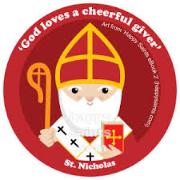

*Lord, I know you are with me and love me.  
Give me peace of mind as I prepare for this time of study.  
Help me to focus on my books and notes,  
keep me from all distractions so that I will make the best use  
of this time that is available to me.*

*Give me insight that I might understand what I am studying,  
and help me to remember it when the time comes.  
Above all, I thank you for the ability to be able to study  
and for the many gifts and talents you have given me.  
Help me always to use them in such a way  
that they honour you and do justice to myself.*

*Amen*

|  |
| --- |
| **Art** |
| **Key skills being tested in this examination:**   * Careful and accurate observation of Shape & Proportion. * Drawing a 3D form. * Tonal contrast. * Shading.   You will be producing an observational drawing of a section of a face. |
| **Key topics to revise for this examination:**   * Drawing with a focus on the Art formal elements. * Revisit recent classwork of how to draw facial features. |
| **Computer Science** |
| **Key topics to revise for this examination:**  E-Safety   * Cyberbullying * Behaving respectably online * Staying safe on social media   Python Programming   * Correct use of functions such as ‘print’ and ‘input’ * Assigning variables * Selection (IF statements) * Data Types   Computer Control   * Flowcharts symbols * Following flowcharts * Definitions of key terms (computer control, flowchart, simulation etc.   [Image result for computing clip art](https://www.bing.com/images/search?view=detailV2&ccid=75FUdAus&id=34485A6AAC3389B436A41A1EBE3DEB9C0A6FF189&thid=OIP.75FUdAusa6XOIhycen1FqgHaF_&mediaurl=http://cliparting.com/wp-content/uploads/2016/05/Computer-system-clip-art-danaalkb-top.png&exph=405&expw=500&q=computing+clip+art&simid=608015398332140056&selectedIndex=7) |

|  |
| --- |
| **Drama** |
| **Key skills being tested in this examination:**  You are being tested on your understanding and knowledge of dance and drama skills.  All of the questions have been created based on the work you have completed in your green booklets over the past year. |
| **Key topics to revise for this examination:**  There are 2 sections to the exam.  In the dance section, you need to revise Rock n Roll, Disco and the most recent topic – Bollywood, as well as your general dance knowledge.  [Image result for drama clip art](https://www.bing.com/images/search?view=detailV2&ccid=9OstEjO9&id=DDB9EE2B95080F16B4E3FC02F69AB6650C98B7BD&thid=OIP.9OstEjO9YVVbfh2ec4oTxQHaHw&mediaurl=http://images.clipartpanda.com/drama-clip-art-Drama.jpg&exph=2364&expw=2256&q=drama+clip+art&simid=608011885019466309&selectedIndex=0)In the drama section you will be asked some general questions together with questions on A Mid-Summer Night’s Dream and characterization, based on the work we did in the first term when we looked at ‘What Has Happened to Lulu?’. |

|  |
| --- |
| **English** |
| **Key skills being tested in this examination:**  You will be examined on your understanding of the play, Macbeth. This will be a reading assessment. You will need to be able to demonstrate the following skills:   * make comments that identify relevantevidence or facts about the play, plot, themes and characters; * consider how Shakespeare reveals ideas through inference; * use quotations to support your ideas and points; * comment on Shakespeare’s use of language to achieve a particular effect; * demonstrate a understanding of the whole text (or at least how much you have studied so far). |
| **Key topics to revise for this examination:**  The story of the play, Macbeth.  The main characters and their relationships to one another.  Key themes you have studied so far  How writer’s use language to achieve particular effects.  How to plan, organize and structure an essay.  How to punctuate quotations.  [Image result for english clip art](https://www.bing.com/images/search?view=detailV2&ccid=KQTkSRf0&id=E4139DFA15DB2E1A7AAC5871D84CA4E366CC2D8B&thid=OIP.KQTkSRf03EwS8kJljEV0ngHaFx&mediaurl=http://www.clker.com/cliparts/q/n/7/N/o/H/language-arts-hi.png&exph=468&expw=600&q=english+clip+art&simid=608024241628381409&selectedIndex=21) |

|  |
| --- |
| **Geography** |
| **Key skills being tested in this examination:**   * Knowledge of a place and how humans interact with the landscape (topic of China). * Human and physical processes along our coastlines. * Being able to accurately read and plot a climate graph. * To be able to describe and explain patterns with valid geographical reasoning. |
| **Key topics to revise for this examination:**  **Within this exam students will be tested on two key topics, China and Coasts. Students will need to revise the following:**  *China*:   * What is unique about China’s culture? * China’s Population Control * China’s Physical Geography * Manufacturing in China   *Coasts:*   * Weathering and Erosion * The Formation of Headlands and Bays * Caves, Arches, Stacks and Stumps * Long Shore Drift * Image result for geographyclip artSpits, Bars and Tombolos * Coastal Protection |

|  |
| --- |
| **History** |
| **Key skills being tested in this examination:**   * Factual knowledge. * Writing extended answers. * Explaining conclusions. * Analysing sources from the past. |
| **Key topics to revise for this examination:**   * Queen Elizabeth I, her portraits and the Spanish Armada. * The Industrial Revolution. * Factory Working conditions during the Industrial Revolution. * The Peterloo Massacre and the problems with democracy in the 1820s.   Image result for history clipart |

|  |
| --- |
| **Maths** |
| **Key topics to revise for this examination:**   * Use the revision list for your set. * Use MyMaths to revise those topics and to attempt the exercises there * Image result for maths clipartRedo some homework tasks from earlier in the year. These will be in the back of your book. You will have done corrections and you can use these to check your understanding.     8y/M3; 8b/M3  8y/M2; 8b/M2  8y/M1a; 8y/M1b; 8b/M1a; 8b/m1b |

|  |
| --- |
| **Music** |

**Year 8 Music revision topics:**

Labelling the keyboard, black and white keys.

Knowing the notes on the stave-Every Good Boy Deserves Football and FACE in the spaces.

Know the shapes and values of the following notes: Semibreve; minim; crotchet and quaver.

Know what the symbols for treble and bass clefs look like and what repeat signs are.

Know the definitions of riff, ostinato, hook and bass line.

We will have a revision lesson the week before your exam and show you where you can locate information to help you revise the topics listed above.

|  |
| --- |
| **RE** |

**The Ten Commandments.**

What are the Ten Commandments?

Who were the Ten Commandments given to?

Why were the Ten Commandments given? Why are they important to Christians?

Are there other important Christian rules/ teachings we must follow?

**Pilgrimage**

What is a pilgrimage?

Why do Catholics go on Pilgrimage?

Where do Catholics go on Pilgrimage?

Who did Mary appear too several times?

What do Catholics do on Pilgrimage?

Can you make comparisons with other faiths?

P**riests/ Bishops and Popes**

Can you name the current Pope/ Bishop/ Parish Priest? What are they in charge of?

Can you describe their roles? Where do they live?

Can you describe some of the symbols the Bishop is given when he is ordained?

What sacraments can they administer?

Explain why being a pope can, at times, be challenging and at other times rewarding.

How do they inspire us?

**Morality**

**What is the difference between moral, immoral, a-moral and non-moral?**

**Is it important that people are moral?**

**Islam**

The belief in Allah and the Prophet Muhammad (PBUH)

Name the followers of Islam/ their Holy Book/ their place of Worship.

The 5 Pillars of Islam/ Going on Pilgrimage to Mecca/ the Ka’ba

**Prejudice and Discrimination**

What does prejudice mean? /What does discrimination mean? What is racism?

How did Jesus respond to prejudice and discrimination?

How do you think prejudice and discrimination affects people’s lives?

Anne Frank and her life story and legacy

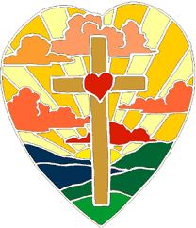

|  |
| --- |
| **Science** |
| **Key skills being tested in this examination:**  Planning a practical   - draw and label scientific equipment  - write a method for an experiment  - name the dependent, independent and control variables  - consider any safety issues (risk assessment)  - draw a line graph or bar chart of results (including any best fit line if needed)  - write and justify a conclusion from your graph |
| **Key topics to revise for this examination:**  There are no specific science topics to revise but any practical work you have done in your exercise books may provide some support in preparing for your exam.  Image result for science clipart |

|  |
| --- |
| **Spanish** |
| **Key skills being tested in this examination:**  **You will be tested in the following skills:**   * **Reading – you will read a number of texts in the present and past tenses and answer questions in English and Spanish.** * **Listening – you will listen to a number of people talking about what they eat and drink in the present and past tenses.** |
| **Key topics to revise for this examination:**  **You will need to revise the whole of Module 1,2,3 and 4 from your Mira 2 vocabulary booklets. This vocabulary is also available on MEMRISE using the link sent out on FROG to all Y8’s by Mr Gerrard.**  **Module 3 – Mis vacaciones**   * **Saying where you went on holiday** * **Modes of transport** * **Activities on holiday**   **Module 1 – La gente**     * **Talking about activities** * **Describing friends and celebrities** * **Daily routine** * **Understanding nationalities**   **Module 4 – La c comida**   * **Talking about mealtime** * **Shopping for food** * **Eating at a restaurant** * **Talking about food -likes/dislikes**   **Module 2 – Vamos a salir**   * **Places in town** * **Going out, inviting someone to go out** * **Making excuses** * **Saying what someone else likes/dislikes**   Image result for spanish clipart |

|  |  |
| --- | --- |
| **Student Examination Reflection** | |
| **Name:** | |
| **Subject:** | **Result:** |
| Art |  |
| Computing |  |
| Drama |  |
| English |  |
| Geography |  |
| History |  |
| Maths |  |
| Music |  |
| RE |  |
| Science |  |
| Spanish |  |
| WWW (What Went Well) |  |
| EBI (Even Better If) |  |
| My SMART target | |

**Revision**

**Why is it important to revise?**

1. Revision helps learning.
2. Revision increases your achievement in tests.
3. Achievement in tests give you wider choices later on.
4. Achievement will make everyone proud of you!
5. You will feel great!

**How to revise?**

1. Make sure you know when your exams are.
2. Make yourself a revision timetable.
3. Revise for 25-45 minutes at a time and have breaks in between.
4. Revise in a well-lit and quiet room.
5. Ban the television when you revise and hide your phone, no distractions.
6. Background music often helps, Mrs Pardoe recommends listening to people playing the piano. Avoid lyrics otherwise you will get confused between what you are hearing and what you are reading.
7. Find a revision technique that works for you, this could be:
   1. Mind maps
   2. Revision cards
   3. Audio recordings (great for languages)
   4. Diagrams
   5. Timelines (for history)
   6. Chars and flowcharts (for processes)
   7. Colours and highlighters
8. Start revision with the stuff you find hard, don’t just revise the stuff you know.
9. Eat plenty of fresh fruit, drink water and eat fish to help your brain!
10. Reward yourself - plan little treats for when you finish your revision.