‘Excellence Through Faith’

Year 10 Information

For Parents/Carers

2019-20
Content:  Key Dates  Exams  Revision  preparation  6th Form  Exam Guidelines  Open Evenings  Year 11 Events | Dear Parents/Carers  Your involvement as a Parent/Carer during this academic year can make all the difference between success and failure.  Parent/Carer support can be up to eight times more important in determining a child’s academic success than anything else.  You do not have to be an expert in the GCSE subjects and exams that your child will be sitting to be able to make a real difference. You just need to know how best to spend your time at each stage of the GCSE process to support their learning.  The hardest demand on our Year 10 students is that of understanding the long term importance of achieving the best they possibly can. Some short term sacrifices may need to be made to ensure they are truly successful.  The aim of this booklet is to provide you – the Parents/Carers – with key dates for the year and to support the GCSE revision process, alongside information on guided revision sessions to aid you in forward planning.  If you have any questions regarding the process, please contact the school for further information.  Year 10 Leader:  h.pardoe@st-nicholas.cheshire.sch.uk
Welcome Year 10
Parents/Carers
What your ATTENDANCE RATE means

Above 97%  95% | Less than 6 days absence a year  Excellent attendance!  Students should achieve the best grades they can.
Less than 10 days absence a year.

They are likely to achieve their target grades.
90% | 19 days absence over a year.  Students are missing a month of school and may drop an exam grade.
85%  80% | 29 days absence in a year  These students are missing 6 weeks of school a year; it will be very difficult to keep up and do their best.
Students with this attendance are missing a YEAR of school over five years of secondary education.

Parents/carers could be issued with a Fixed
Penalty notice.

The importance of good attendance cannot be over stated, especially in Year 11as a structure may not have the opportunity to be right subject content missed
E-Safety– see Childnet for more information to stay safe.

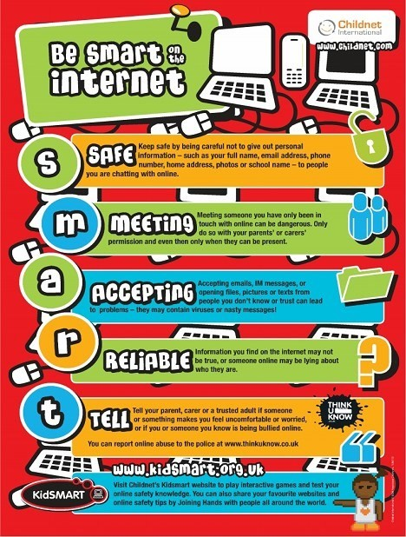

Key dates

- Year 10 Parents Evening- Thursday 9th January
- Year 10 SEN Information Evening- Tuesday 17th March
- Year 10 Retreat- Week Beginning 2nd June (Please note students will be departing on different days during that week.)
- Year 10 Exams- 18th-26th June

RM
A GCSE Mindset

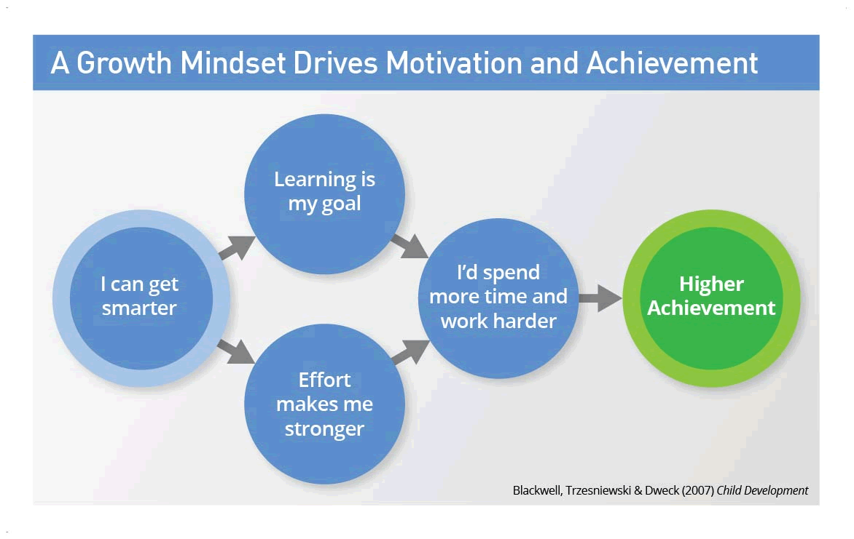

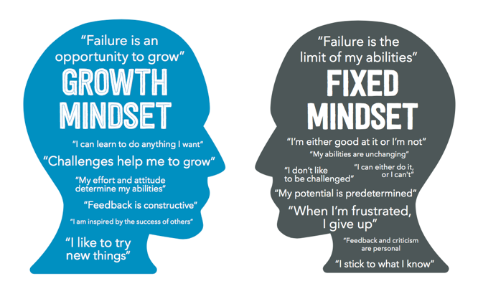

Revision Do’s and Don’ts

DO

1. Make a list of all the topics you need to revise

2. Create a realistic schedule.

3. Plan ahead by working backwards

4. Revise using your preferred learning style.

5. Take breaks and chunk working time (no more than 40 minutes)

D O N ’ T

Just keep going! The body and the mind need regular
'time-outs'.

Use breaks effectively, particularly after completing a task.
Revision Ideas

- Mind mapping
  - Put diagrams up in the house
- Talking to somebody
- Questioning each other
- Flash cards
- Talk out loud
- Even record yourself
- Condense notes
- Highlight notes
- Test yourself
  - Time yourself doing past paper questions
- Use websites e.g bitesize or Seneca Learning

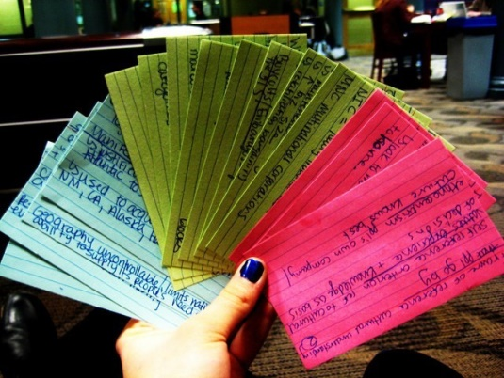
Improve your memory:

Chunking information
Repetition
Association
Use mnemonics

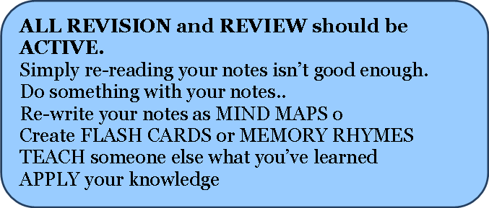
Revision Timetable

RM

Produce an exam calendar and put it up at least 6-8 weeks before the start of the exams.

- Make a list of what you need to revise-subjects and the topics within them

- Highlight subjects and topics which you find the most difficult-allow more time for these.

- Block out times when you can’t revise. Count up the available slots and divide this by the number of subjects you have to revise for.

- Enter revision slots for each subject onto timetable. As exams get closer be more specific. It may be useful to produce a weekly timetable as well as an overview (see examples).

- Ideally revise each subject in advance then also a week before and a day before.
Post 16 Choices

RM

RM

A-levels
Apprenticeships
Vocational Qualifications Levels 1-3
Employment with training

Students must be encouraged to make the correct choices for their own futures. It is important that they choose a course that is at the correct level for them and that they will enjoy.

Questions they need to ask themselves are:
Do I want to learn in a classroom or would I prefer to learn in a practical environment?
Do I want to sit a lot of exams or would I prefer a coursework based subject?
Do I want to be writing a lot of essays or would I be better being
examined in a practical context?

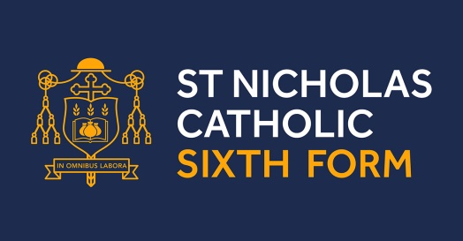

- Outstanding pastoral support – help when you need it
- Small class sizes
- 38% students in 2018 progressed to a Russell Group University this number increased to 47.5% 2019
- Daily contact with a form tutor
- Improved facilities
- Tailored Enrichment programme to allow all students to explore their individual areas of interest
- A Sixth Form community
- An inclusive Sixth Form supporting students from 7 Grade 4’s to 10 Grade 9’s

We believe, unequivocally, that St Nicholas Sixth Form offers students the independence of a college but with the personal support and guidance of a Sixth Form.

The new prospectus will be available on Open Evening

Mr. Bradley is available to contact should you need any further information at:
t.bradley@st-nicholas.cheshire.sch.uk

Choices in Education

RM

Learning in college or sixth form
If students want to continue learning in a college or sixth form, they could study for academic qualifications such A Level’s or go for work-related qualifications such as BTECs and City and Guilds . Diplomas combine classroom learning with practical hands on experience with many of the vocational course at colleges. Diplomas aim to provide work-orientated skills in a more creative way - so students get practical training and benefit from work experience. There is less classroom-based learning than with A levels.

For more information on any of the colleges in the
Cheshire area please visit their websites.

A course that leads to an Apprenticeship Apprenticeships give young people the chance to learn — and gain nationally recognised qualifications — while getting a weekly wage.
If a student hasn’t found an employer to do an Apprenticeship with, they can start a ‘Programme-led Apprenticeship’.
This means they will begin their studies at college— and get some work experience — before they move on to an Apprenticeship with an employer.

For more information on a course that leads to

Year 10 Recommended Book List

Subject | Book Title (Inc. Publisher) | ISBN |  | Cost | Any additional information
Business Studies | Business Studies: Edexcel GCSE 9-1 Business. Ian Marcouse. Second Edition. | 978 -1471899355 |  | £23.00
Business Studies | Revision Guide for Edexcel GCSE 9-1 Business and workbook | 1292190701 |  | £5.99
Drama | AQA GCSE Drama | 978 1911208211 |  | £22.60
Economics | Economics: OCR GCSE 9-1 Economics. Riches, Bancroft and Miles-Kingston. 2017. | 978-1471888342 |  | £25.00
English Language | Oxford Revision Workbook - Targeting Grades 6-9 | 978-0198359180 |  | £5.99 | For students aiming for higher grades
English Language | Oxford Revision Workbook - Targeting Grade 5 | 978-0198359197 |  | £5.99 | For students working up to grade 5
English Literature | York Notes - Jekyll and Hyde | 978-1447982180 |  | £4.75
English Literature | York Notes - An Inspector Calls | 978-1447982166 |  | £4.75
English Literature | York Notes - Romeo and Juliet | 978-1447982234 |  | £4.75
Food Preparation and Nutrition | 9-1 GCSE Food Preparation & Nutrition - AQA Revision Guide | 1782946497 |  | £5.95
Food Preparation and Nutrition | AQA GCSE Food Preparation & Nutrition: Revision Guide | 1908682809 |  | £12.99
GCSE French | AQA French Foundation | 978 019 836584 6 |  | £23.50 | Pupils have access to it via Kerboodle with a login
GCSE French | AQA French Higher | 978 019 836583 9 |  | £23.50 | Pupils have access to it via Kerboodle with a login
GCSE RE revision book | My Revision Notes Edexcel Religious Studies for GCSE (9-1): Catholic Christianity (Specification A): Faith and Practice in the 21st Century (Hodder) | ISBN 978-1-510-40480-9 |  | £9
GCSE Spanish | AQA Spanish Foundation | 978 019 836586 0 |  | £23.50 | Pupils have access to it via Kerboodle with a login
GCSE Spanish | AQA Spanish Higher | 978 019 836585 3 |  | £23.50 | Pupils have access to it via Kerboodle with a login
Geography | GCSE Geography AQA Student Book (Oxford) | 198366612 |  | £25 | Text book used in lessons
Geography | New Grade 9-1 GCSE Geography AQA Revision Guide (CGP) | 1782946101 |  | £6
Geography | New Grade 9-1 GCSE Geography AQA Exam Practice Workbook | 178294611X |  | £5
History | Oxford AQA GCSE History: Germany 1890-1945 Democracy and Dictatorship | ISBN 978-0-19-842289-1 |  | £5.99
History | Oxford AQA GCSE History: Elizabethan England | ISBN 978-0-19-842293-8 |  | £5.99
History | Oxford AQA GCSE History: Britain: Health and the People c1000-Present Day Revision Guide (9-1) | ISBN 0198422954 |  | £5.99
History | My Revision Notes: AQA GCSE (9-1) History (Hodder Education) | ISBN 151040404X |  | £9.99 | Covers all of the units
History | Germany Revision Guide and Workbook | ISBN 978-1-292-20476-5 |  | £5.99
Maths Foundation | Edexcel GCSE Maths Foundation Exam Practice Workbook for the 9-1 course | 978 1 78294 399 0 |  | £5.95
Maths Higher | Edexcel GCSE Maths Higher Exam Practice Workbook for the 9-1 course | 978 1 78294 403 4 |  | £5.95
Maths Foundation | Edexcel GCSE Maths Foundation Revision guide for the 9-1 course | 978 1 78294 400 3 |  | £5.95
Maths Higher | Edexcel GCSE Maths Higher Revision guide for the 9-1 course | 978 1 78294 404 1 |  | £5.95
PE | New GCSE Physical Education Revision Guide - for the Grade 9-1 Course | 978 1 782945321 |  | £5.95
Science Foundation | New Grade 9-1 GCSE Combined Science: AQA Revision Guide with Online Edition - Foundation | 978 1782945604 |  | £9.48
Science Foundation | New Grade 9-1 GCSE Combined Science: AQA Exam Practice Workbook - Foundation | 978 1782944867 |  | £9.95
Science Higher | New Grade 9-1 GCSE Combined Science: AQA Exam Practice Workbook - Higher | 781 7 8294 485 0
Science Higher | New Grade 9-1 GCSE Combined Science: AQA Revision Guide with Online Edition - Higher | 978-1782945598 |  | £9.15
Separate Sciences | Grade 9-1 GCSE Biology AQA Revision Guide  Grade 9-1 GCSE Chemistry AQA Revision Guide  Grade 9-1 GCSE Physics AQA Revision Guide | 978-0008160678  978-0008160685  978-0008160692 |  |  | Available via ParentPay or Amazon sell all 3 for around £15
Science online Textbooks are also available via Kerboodle (online). Login Required.
YEAR 11 Product Design | New Grade 9-1 GCSE Design & Technology AQA Exam Practice Workbook |  | 1782947531 |  |  | £5.95
YEAR 11Product Design | New Grade 9-1 GCSE Design & Technology AQA Revision Guide |  | 1782947523 |  |  | £5.94
YEAR 11 Product Design | AQA GCSE (9-1) Design & Technology |  | 1910523100 |  |  | £20 | Text book used in lessons
Year 11 Computer Science | New GCSE Computer Science OCR Revision Guide - for the Grade 9-1 Course |  | 9781782946021 |  |  | £6 | Already issued to students- must be returned at the end of Year 11
Year 11 Computer Science | New GCSE Computer Science OCR Exam Practice Workbook - for the Grade 9-1 Course |  | 9781782946038 |  |  | £6 | These will be given to the students for homework activities.

