Expedition: Silver Training
For: St. Nicholas High School
Date: Sat 30th March – Monday 1st April 2019

 | Location | Map | Description
Start  Time 10:00 | Hayfield Countryside Centre.  SK22 2ES | 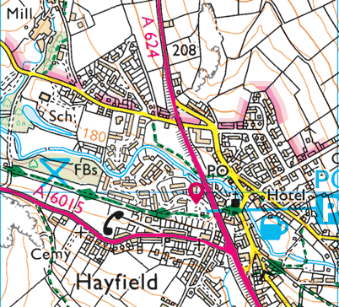 | The Visitor’s Centre is located just north of the junction between the A6015 with the A624 in Hayfield. Parking and toilets are available although the visitor centre itself closed in March 2017.
Camp 1 | Coopers campsite  New Fold Farm,  Grindsbrook Booth  S337ZD | 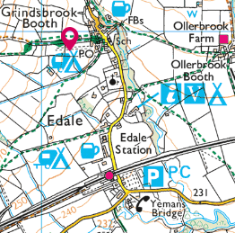 | Coopers campsite is located north of Edale station. Follow the lane past a campsite on the right and the church on the left. Coopers is the next left turn.
Camp 2 | Hardhurst Farm campsite  S336RB | 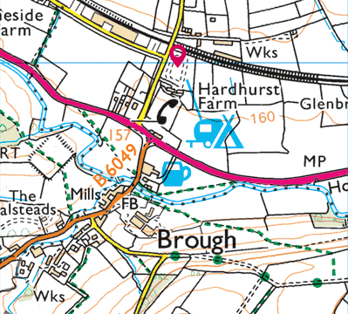 | From Cheshire your likely approach to Hardhurst is via Castleton and Hope on the A6187. To access the camp site, turn left at Brough, approx. 2.5 miles east of Castleton
Finish Window  Time 14:00-15:00 | Mam Nick car park  S33 8WA | 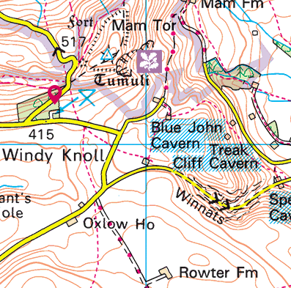 | Car park to the southwest of Mam Tor in Derbyshire; 2 miles west of Castleton; not far from Winnets Pass and Blue John Cavern. National Trust car park, so free for members; otherwise pay and display.

